20+ Jaw-Dropping Guerrilla Marketing Examples


Megan Marrs, Wordstream

Last updated: October 17, 2018

Marketing Ideas

When the classic strategies aren’t delivering, you send in the guerrillas. They’re the extra-special forces – the ones that implement killer strategies to turn the tide and defeat the enemy.
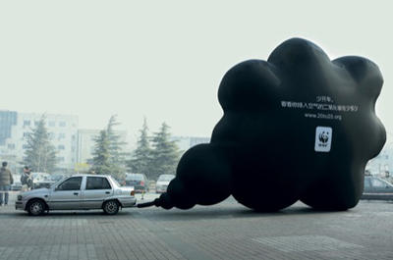
Guerrilla marketing is a great alternative to traditional marketing. It thrives on original thinking and creativity, where imagination and ingenuity beat out big budgets.
Guerrilla marketing tends to be cheaper than traditional marketing, relying on smaller, more localized brick and mortar strategies like:
Graffiti: Graffiti marketing uses city streets and alleyways as a giant canvas. While smaller, more covert operations will make their mark wherever they want, for most businesses it’s recommended to get permission from a property owner before going Monet on the walls of their establishment.
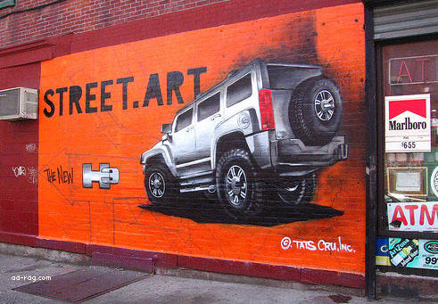
Guerrilla marketing, graffiti-style
Stencil Graffiti: Stencil graffiti uses stencils to create repeated works of street art. The advantage of stencils is that you can create multiple instances of your art across many different spaces in a short period of time. Stencils tend to be small in size (as opposed to a full-wall mural) and consist of simple designs.
Reverse Graffiti: Reverse graffiti is when, instead of adding to a surface, marketers remove dirt and grime from a street or wall to create an all-natural marking message. Just put a stencil on a sidewalk and then wash the uncovered spaces!
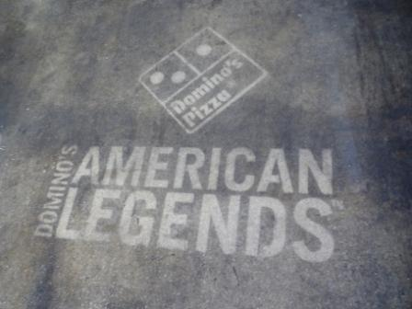
A reverse-graffiti sidewalk ad
Stickers: Creative use of stickers is another great guerrilla marketing tactic that can be very successful when implemented well.
Undercover Marketing: Also known as “stealth marketing,” marketers disguise themselves as peers amongst their target audience. One example is Sony’s campaign in 2002, in which actors were hired to wander about cities, asking strangers to take a photo of them. During the interaction, actors would rave of their cool new phone, boasting of its features and capabilities.
Flash Mobs: Flash mobs involve organizing a group of individuals to perform a specific action or task at a pre-determined location and time. In some cases participants are hired actors, other times they are simply members of the community who enjoy the randomness of flash mobs!
Publicity Stunts: Publicity stunts involve specific feats of awe and amazement, usually sponsored or in partner with a brand. Red Bull is very adept at this practice, exemplified by their 2012 skydiving record as part of their Stratos project. Red Bull sent Austrian extreme-sports athlete Felix Baumgartner above the stratosphere, dominating the world record for highest skydive, launching himself from over 128,000 feet above earth. Arguably much more than a mere stunt, the Red Bull Stratos project set numerous world records and was viewed live on YouTube by over 9.5 million users (setting yet another record).
Treasure Hunts: Creating custom, high-quality treasure hunts is another cool guerrilla marketing tactic that can energize audiences. Guerrilla marketing treasure hunts often involve posting online clues to hidden items scattered across a single or several cities. Winners are rewarded with digital codes, prizes, or a hint for the next level of the treasure hunt.
Urban Environment: The most successful guerrilla marketing strategies make great use of the spaces around them. Urban environments allow for many opportunities to implement clever marketing strategies.
While today we’re mostly showing physical, visual examples of guerrilla marketing, there are plenty of online examples. Online guerrilla marketing campaigns often appear in the form of:
- Viral videos
- User generated content competitions
- Creative landing pages

Guerrilla Marketing Pros and Cons
Guerrilla marketing has some advantages and disadvantages. Take both into consideration before choosing to move forward with a campaign.

Pros of Guerrilla Marketing
- Cheap to execute. Whether using a simple stencil or a giant sticker, guerrilla marketing tends to be much cheaper than classic advertising.
- Allows for creative thinking. With guerrilla marketing, imagination is more important than budget.
- Grows with word-of-mouth. Guerrilla marketing relies heavily on word-of-mouth marketing, considered by many one of the most powerful weapons in a marketer’s arsenal. There’s nothing better than getting people to talk about your campaign on their own accord.
- Publicity can snowball. Some especially noteworthy or unique guerrilla marketing campaigns will get picked up by local (and even national) news sources, resulting in a publicity powerhouse affect that marketers drool over.

Cons of Guerrilla Marketing
- Mysterious messages can be misunderstood. There’s often an air of mystery to guerrilla marketing campaigns, and while it’s this sense of mystery that can often propel a campaign’s attention and notice, the lack of clarity can also skew audience interpretation.
Confusion associated with guerrilla marketing campaigns can have extreme implications, such as in 2007, when flashing LED circuit boards promoting a new animated series, Aqua Teen Hunger Force, were quietly installed around the city of Boston. The objects were mistaken for explosive devices, causing citywide panic as bomb squads were brought in to examine and remove the unknown devices.
The hired installers were even arrested for mounting “hoax devices,” but were later released. While it’d be easy to label this campaign as a disaster, the story got picked up on major media networks across the country, so despite whole ordeal, some would probably call it a success.
- Authority intervention. Some forms of guerrilla marketing, such as non-permissioned street graffiti, can result in tension with authorities.
- Unpredicted obstacles. Many guerrilla marketing tactics are susceptible to bad weather, thrown timing, and other small instances that could easily threaten to undermine an entire campaign.
- Potential backlash. Savvy audiences may call out businesses who are implementing guerrilla marketing campaigns they don’t approve of. This is especially true of undercover marketing campaigns – if you’re caught, prepare to face the wrath.
There’s no doubt that guerrilla marketing can provide fantastic results while allowing marketers to exercise their creativity in a unique way, but it will only work for businesses who aren’t afraid of risk-taking.

20 Real-World Examples of Guerrilla Marketing
Axe Body Spray uses custom stickers attached to the classic “exit man” signs that are so commonplace in establishments everywhere. The added stickers create a story about the familiar exit man – and to think all this time we thought he was escaping from a fire!
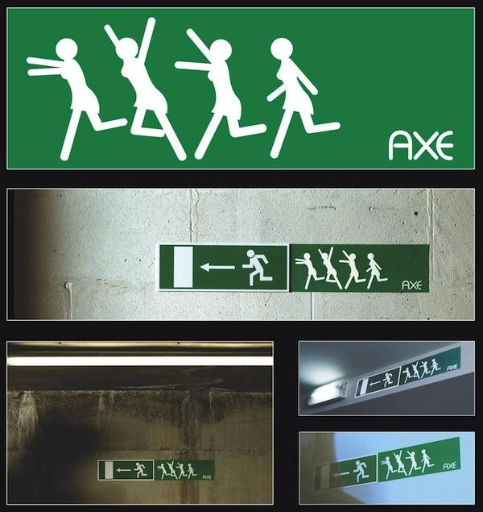
Axe's guerrilla marketing stickers show women chasing the men on Exit signs
Guinness adds small custom wraps to pool cues in bars, offering a clever reminder to pool players to grab a brew. This guerrilla marketing strategy is not just adorable - it also does a great job of targeting Guinness’s key audiences by working off of existing bar paraphernalia.
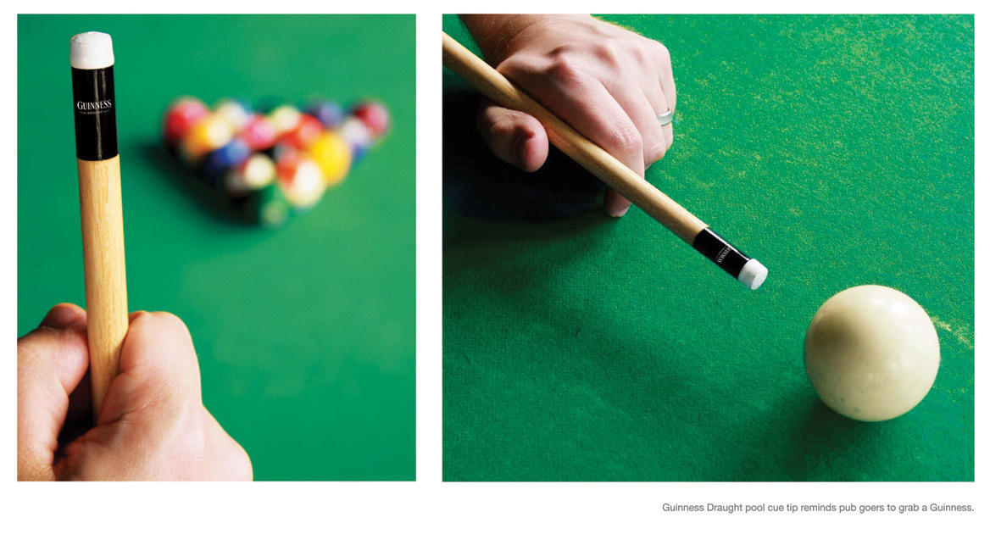
Guinness's pool cue guerrilla marketing stunt
Discovery Channel reminds beach goers about upcoming Shark Week by placing these bitten boards along beaches.
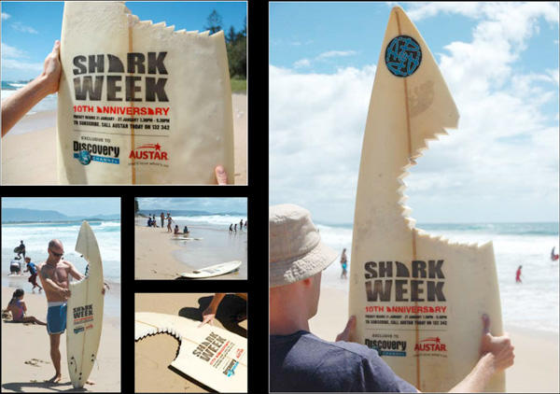
Shark Week guerrilla marketing boards
These unusual towels serve as not-so-subtle warnings to sun soakers tanning on the beach.
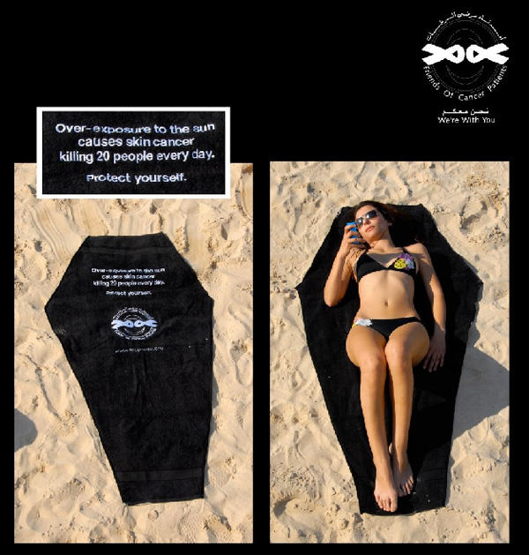
Coffin-shaped beach towels raise skin cancer awareness
Guerrilla marketing isn’t just found in urban settings – it can be found in print too. This Weight Watchers magazine advertisement changes shape as users remove perforated pieces.
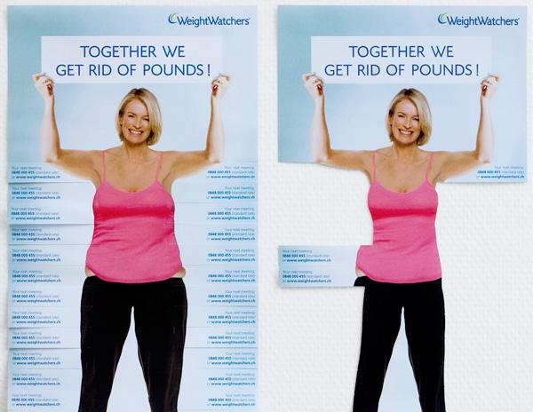
Clever contextual marketing from Weight Watchers
This sticker was placed on the floor of elevators, giving riders a taste of the Swiss Skydive experience.
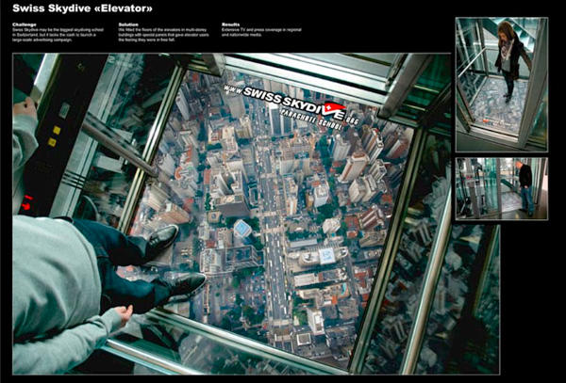
Unexpected marketing on an elevator floor
An organization raising awareness of Alzheimer’s created an ingenious marketing strategy involving city maps. These free Hamburg city maps were given out at tourist booths. When users opened the map, they saw only a mess of unmarked, unlabeled road, mirroring the confusion and sense of misplacement associated with Alzheimer’s disease.
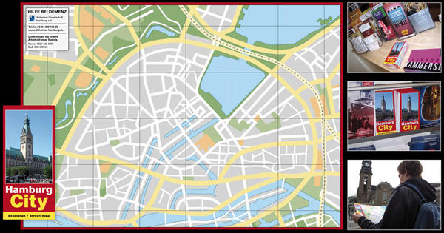
Raising awareness of Alzheimer's disease with sneaky marketing
There’s no shortage of stairs in the world, and many genius guerrilla marketing tactics make use of staircases for their own benefit. This IKEA ad reminds users of how IKEA furniture works to save space in your home.
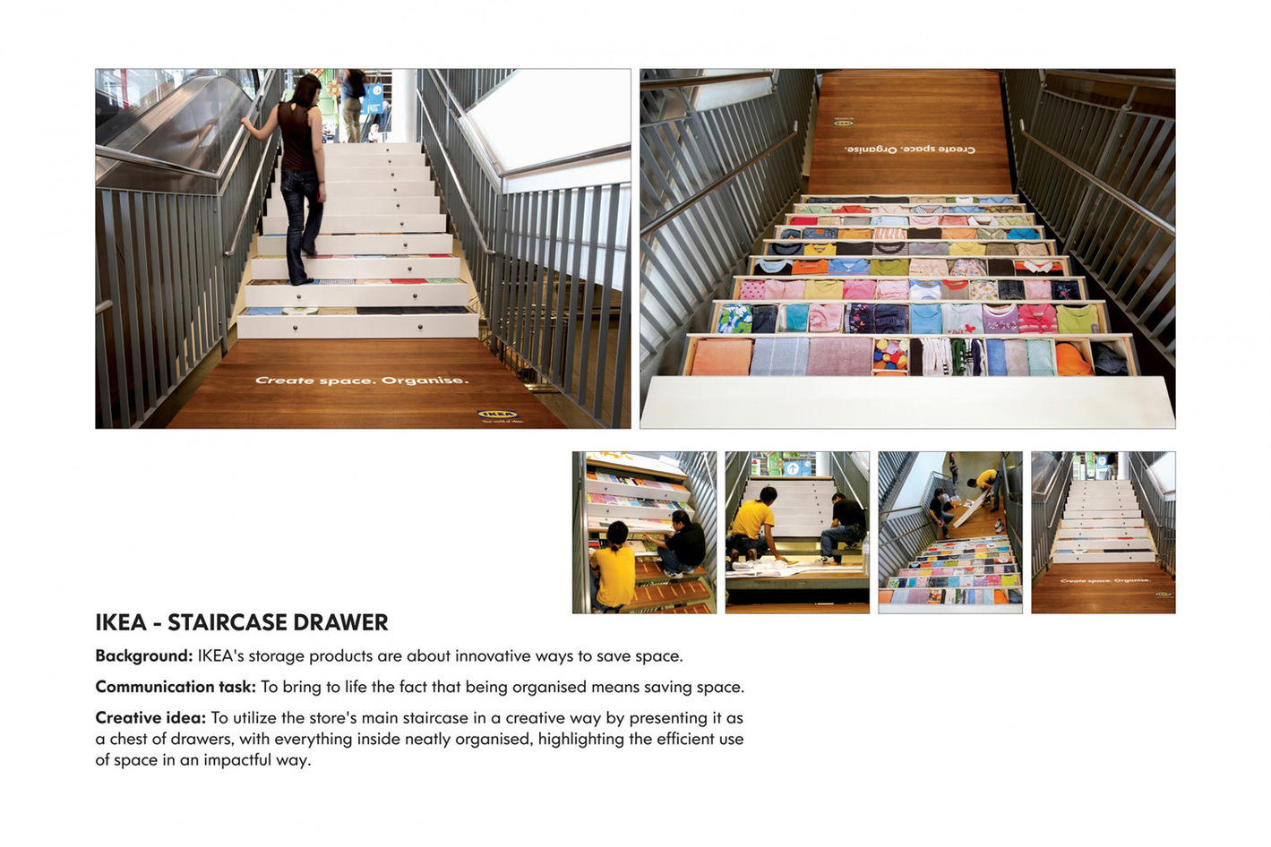
Guerrilla marketing on a public staircase
This guerrilla marketing campaign for King Kong 3D had people snapping photos and sharing their experiences on social media.
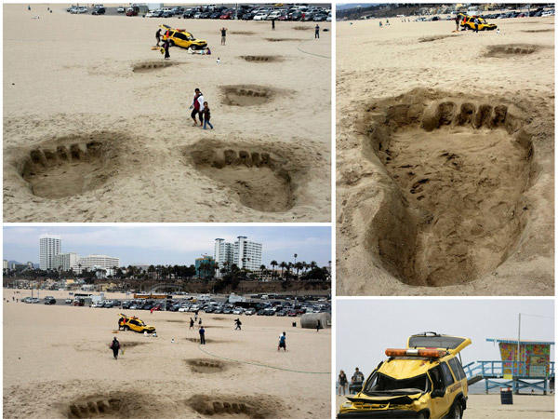
Guerrilla marketing for King Kong 3D on the beach
Similar to the elevator ad above, this ad for the Maximum Ride book series uses the edge of an outdoor staircase as a tool in their optical illusion.
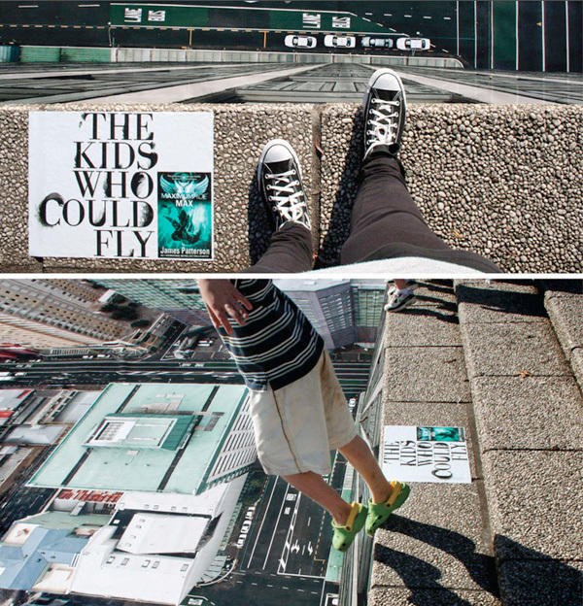
Hope you're not scared of heights!
Crosswalks are another urban structure often used by guerrilla marketers. In this example, Mr. Clean shows off his cleaning power on a crosswalk.
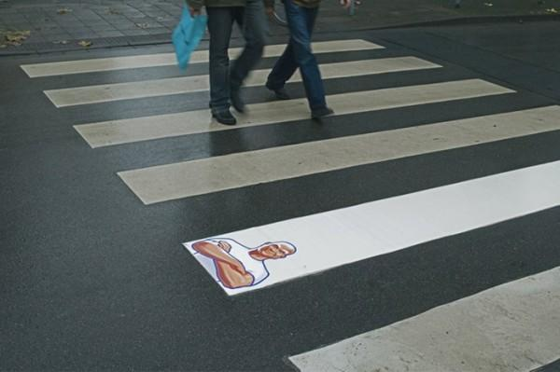
Mr. Clean pulls off a great guerrilla marketing gag on a city crosswalk
National Geographic reminds users just how hard it is to capture that perfect shot.
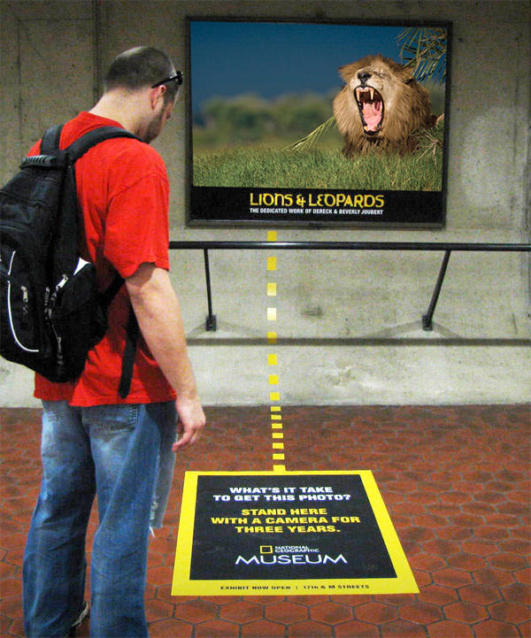
This ad at the Nat Geo Museum also markets the magazine
Beau Rivage Resort Casino uses airport baggage belts to capture users’ attention as they wait for their luggage. It’s also another great example of audience targeting, as people who can afford to travel are good potential customers for a resort casino.
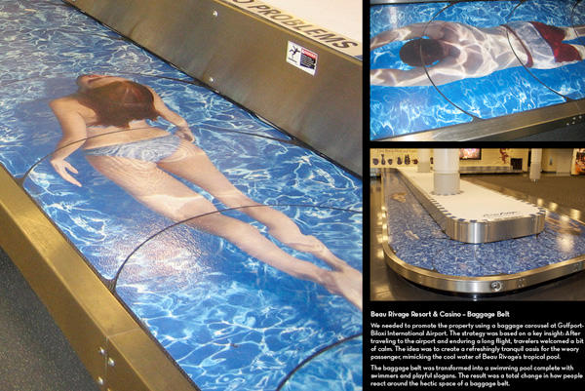
Casino and resort ad at the airport targets frequent travelers
Tyskie beer turns a regular door handle into a call for a cold brew.
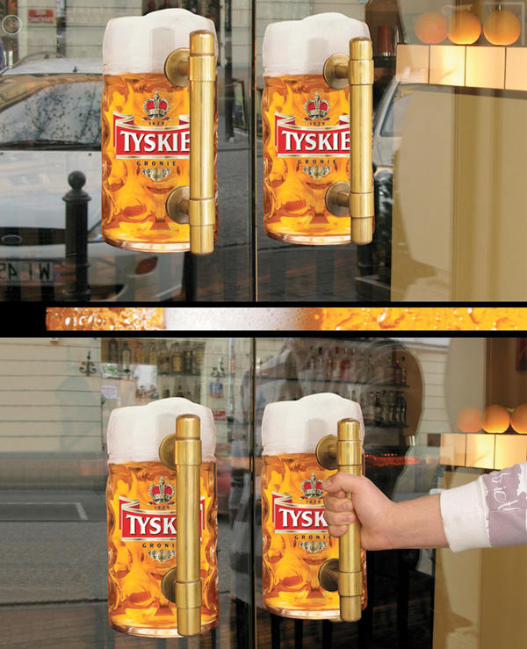
Repurposing door handles for beer mugs
Unicef reminds city-dwellers of the millions of people around the world who do not have access to clean drinking water.
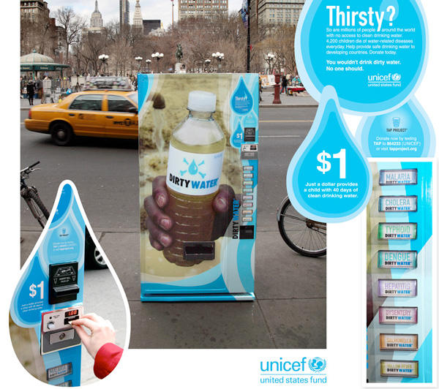
Another great guerrilla marketing campaign from a nonprofit
Duracell adds their flashlight posters to illuminated areas, reminding users of the power of Duracell.
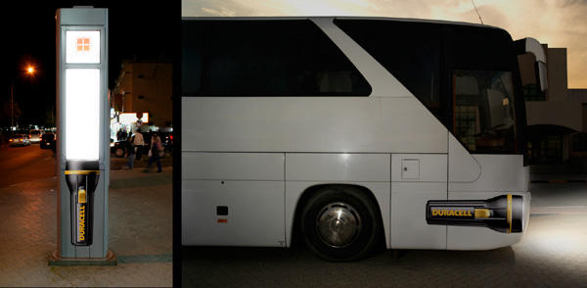
Duracell's contextual ads make use of existing light sources
Cover Girl makes clever use of a city turnstile to mimic their Lash Blast Mascara application comb. (This example has to be my favorite!)

Cover Girl's brilliant use of a turnstile to mimic a mascara wand!
Burn 60 makes creative use of a drawstring bag in this physical piece of guerrilla marketing. In an industry packed with false promises and big talk, the simplicity of this design sets it apart from other health and diet pill peddlers.
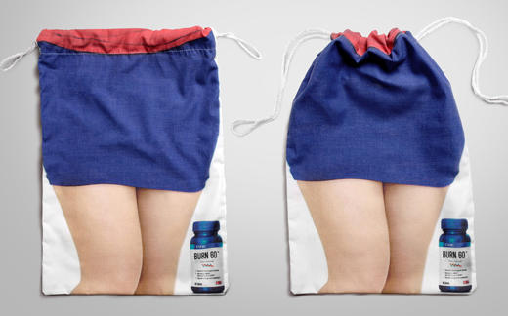
Another clever use of marketing to sell weight-loss products
The Copenhagen Zoo covers a local bus in a custom design, which catches eyes all over the city.
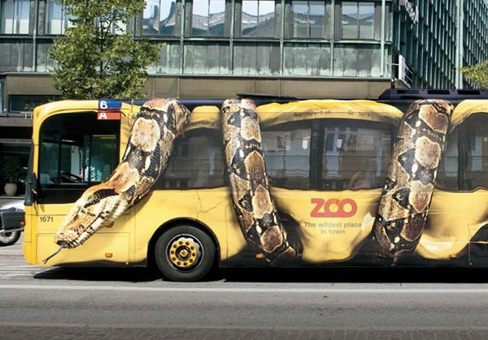
Awesomely eye-catching marketing on a city bus
Colgate creates toothbrush-shaped wooden popsicle sticks to inset into ice cream bars, reminding children (and adults) of the importance of brushing. Presumably the importance of brushing with Colgate.
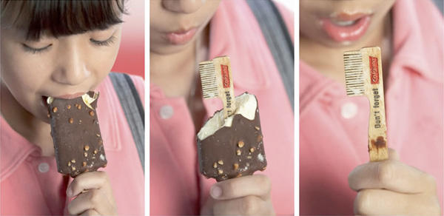
Toothbrush-shaped popsicle sticks: Surprise!
This disturbing (but effective) guerrilla marketing strategy from Campaign Against Landmines uses restaurant ketchup packets to drive home the horrors of landmines and the injury to innocent victims in war-torn countries.
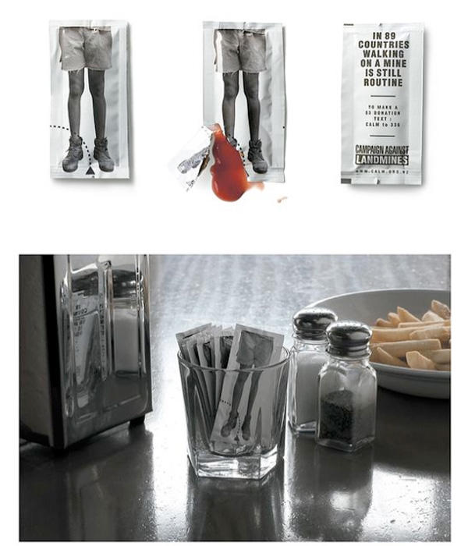
These ketchup packets conceal a powerful marketing message
Note: Images in this post were borrowed from Creative Guerrilla Marketing, Creative Pool, Guerilla Freelancing, and Prosar. Check them out for even more examples.
As you walk home today, look at your surroundings and try to pick out the setting for your guerrilla marketing campaign – stairs, benches, and street corners could become your marketing masterpiece.
Do you have any favorite examples of guerrilla marketing we missed? Share your thoughts in the comments below!


Megan Marrs
Megan Marrs is a veteran content marketer who harbors a love for writing, watercolors, oxford commas, and dogs of all shapes and sizes. When she's not typing out blog posts or crafting killer social media campaigns, you can find her lounging in a hammock with an epic fantasy novel.

FREE Google Ads Performance Grader

