20 Selling Techniques That Will Actually Improve How You Sell
By Tim Riesterer, Chief Strategy Officer
Corporate Visions—Conversations that Win
September 10, 2019

Who couldn’t use an arsenal of effective selling techniques? If you truly want to improve how you sell, look no further than this research-backed collection of the very best B2B sales techniques, as well as four ineffective (but popular) ideas for how to sell.
This article includes 20 selling techniques organized into six sections. You can jump to a specific section using one of the links below, or just scroll down for the complete list.
- Sales Prospecting Techniques
- Selling Techniques That Create Value
- Phone Sales Techniques
- Sales Closing Techniques
- How to Sell to Existing Customers and Expand Value
- Sales Techniques That Don’t Work

Sales Prospecting Techniques
Grabbing your buyer’s attention and opening the door to more fruitful sales conversations is the key to effective sales prospecting. Use these three sales prospecting techniques to build your pipeline and have more productive conversations with your prospects.

Make Your Customer the Hero
There’s a large body of research about the cognitive effects of stories for motivating behavior change. And in a selling context, stories are a powerful way to illustrate the value of your solution to your prospect. Every story needs a hero—someone you relate to as they overcome obstacles on their journey toward happily ever after. But who’s the hero of your story? If it’s your company or your solution, you need to rework your story and make the customer the hero.
A typical hero’s journey goes something like this:
- The hero is a character who struggles with a problem
- The hero meets a wise mentor who understands their problem
- This mentor gives the hero new insight, provides a plan, and drives them to action
- Armed with newfound confidence and a plan, the hero faces their problem
- The hero overcomes the problem, realizes their potential, and reaches their goal
In your story, the customer is the one who needs to save the day, not you. Your role is that of the mentor. You’re there to help your customers see what has changed in their world and how they can adapt to better survive and thrive.

Don’t Over-Personalize Your Campaigns
Most marketers and salespeople believe the more personalized your outreach, the better your results. But you may be surprised to discover that highly personalized outreach isn’t as effective as less time-intensive personalization.
In a recent B2B personalization study, we tested the effectiveness of four different email personalization methods with 7000 prospects to determine which treatment worked best. We used four different personalization conditions—industry only, company only, industry + personal details, and company + personal details.
The results? While open rates were higher when using more personal details, the opposite was true for click-throughs. Personalizing by industry (without personal details) returned a 24 percent higher click-through rate than the company + personal details treatment.
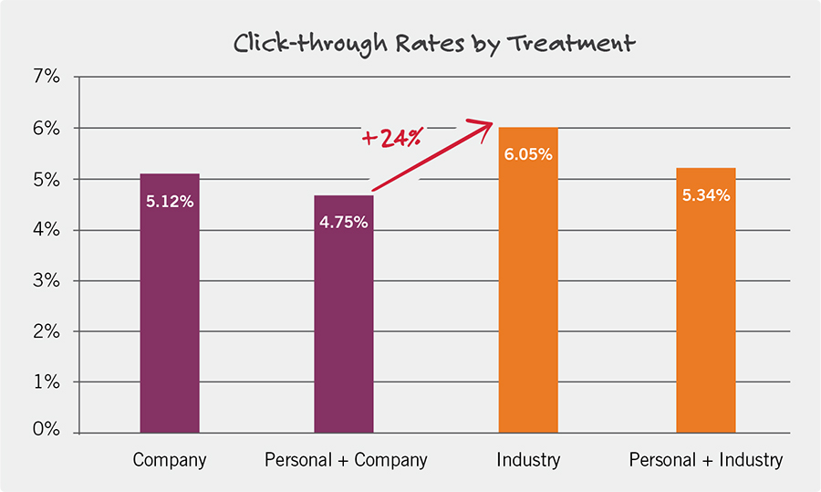
People may initially open an email that appears to speak directly to them. But they’ll feel let down when they discover it’s only a clever gimmick to grab their attention. On the other hand, when you share a story about how a similar company struggled and solved a common industry concern, your prospect is better able to project themselves into the story. They may even be eager to find out what happened next.
Learn more about the most effective approach to B2B marketing personalization in our e-book, It’s Not Business, it’s Personal.

Use “You” Phrasing, Not “We” Phrasing
It seems well-intentioned and inherently logical: Show your customers you understand their world by positioning yourself as a member of their tribe, hoping to establish a collaborative experience. The word “we” implies the supplier and the buyer are “in it together.” The problem is, when you use this type of we-phrasing, you’re actually hurting your ability to move your prospect to take action.
Corporate Visions ran two studies to test the effectiveness of you-phrasing versus we-phrasing. The studies found that you-phrasing is exponentially more effective at moving prospects to take personal responsibility and feel like they must take action. You-phrasing compels your prospect to question their status quo, paints an achievable buying vision, and holds your prospect’s attention in a way that separates your message from the competition.
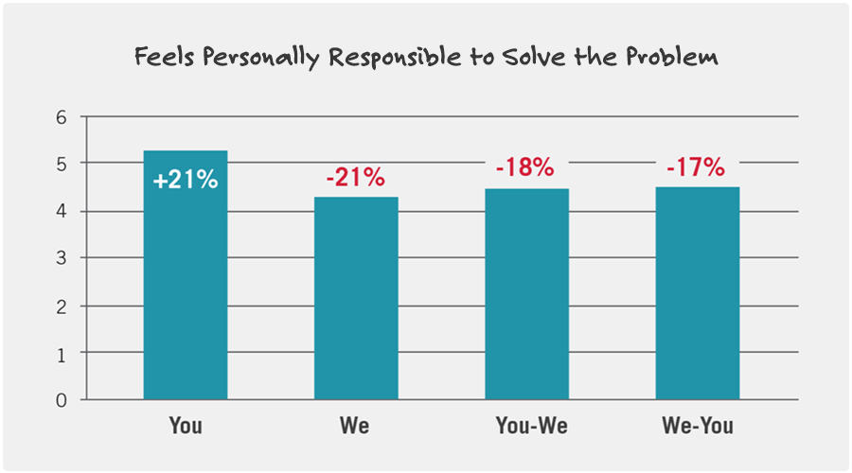
So, the next time you’re talking to a potential buyer, use you-phrasing. It’s a small change. But it makes a big difference.
Learn more about you-phrasing in our State of the Conversation Report, The Impact of You-phrasing on Customer Conversations.

Selling Techniques That Create Value
Use these four selling techniques to show your prospects why they need to change their situation and persuade them to choose you over your competition.

Challenge Your Prospect’s Status Quo
Many salespeople see the sales process as linear. At some point, it has an end—the prospect will choose either you or your competitor. The truth is that those aren’t the only two endpoints. There’s another option—no decision—which is chosen all too often.
Studies show that at least 60 percent of deals in the pipeline are lost to “no decision” rather than to competitors. That’s because of something called Status Quo Bias—your prospect’s natural aversion to doing something different than what they’re doing today. It’s only by disrupting their status quo that you can persuade your prospects that their current situation is unsafe and unsustainable.
Keep in mind, however, that this conversation is about why your buyer needs to change. It’s not about introducing your solutions’ features and benefits. At this point, focus on creating the urgency to change by establishing that your prospect’s status quo situation is preventing them from reaching their most important business goals.
Learn more about when you should (and shouldn’t) challenge your buyer’s status quo in our e-book, To Challenge or Not to Challenge.

Introduce Unconsidered Needs
Too often, salespeople base their messaging on the needs prospects tell you they have. When you do that, you’re then inclined to connect those identified needs to the specific capabilities that respond to those needs—in the standard “solution selling” fashion.
The problem is, you end up delivering commodity messages that won’t differentiate you from your competitors—because they’re likely constructing a similar value message in response to the same set of inputs. And because every option sounds the same, your prospects become indecisive. To create the urgency to change and overcome Status Quo Bias, you need to introduce prospects to Unconsidered Needs—unmet, underappreciated, or yet uknown problems or missed opportunities that are holding back their business.
In fact, research conducted by Corporate Visions found that a provocative messaging approach that begins by introducing an Unconsidered Need enhances your persuasive impact by 10 percent. Learn more about Unconsidered Needs in this short video:

Find Your Value Wedge
When you present your value proposition to prospects, how much overlap is there between what you can provide and what your competition can provide? Most B2B salespeople admit that overlap is 70 percent or higher. So rather than competing within that “value parity area,” focus on what you can do for the customer that’s different from what the competition can do. This is called your Value Wedge.

Your Value Wedge must meet three important criteria:
- It’s unique to you. This is a message that’s completely different than your competitors.
- It’s important to the customer. Provide value by highlighting gaps in the way your prospect is doing things today, and how your approach will resolve those issues.
- It’s defensible. Document proof points of times when other companies overcame similar challenges by adopting your proposed solution.
And when you create something that meets those three criteria, you have a value proposition that sets your solution apart from the competition and communicates real value to your prospect.
When you connect your prospect’s Unconsidered Needs to your differentiated strengths, you break free from value parity and commodity messaging to create the urgency and differentiation needed to overcome your prospect’s Status Quo Bias.

Tell Compelling Visual Stories
“Death by PowerPoint” is a common way to describe the mind-numbing experience of sitting through a long slide presentation filled with bullet points and clip art. Yet, most sales reps continue to fall back on this tired and unoriginal method of pitching.
But research proves that effective sales presentations need to go beyond just a list of bullets. A research study we conducted on using visuals in B2B sales revealed that simple, concrete, hand-drawn visuals on a whiteboard outperformed two types of PowerPoint presentations in the areas of recall, engagement, presentation quality, credibility, and persuasion.
Sales presentations should be a compelling visual narrative designed to showcase your products and services and how they deliver unique value. And regardless of whether you use a whiteboard, a flip chart, the back of an envelope, or a tablet, using visual stories is a powerful differentiator in competitive and complex selling environments.

Phone Sales Techniques
Most of the selling strategies in this article are still effective when you’re selling over the phone, but you can use these two specific phone sales techniques to boost your persuasive impact and close more deals.

Tailor Your Message for Virtual Sales
Many companies are expanding inside sales teams. In fact, the majority of B2B salespeople we surveyed conduct more than half of their sales calls in non-face-to-face environments. But for all the potential cost savings and productivity gains, inside sales can create engagement challenges due to the virtual barrier between seller and buyer.
In a face-to-face meeting, you likely have your prospect’s full attention. But over the phone or in a virtual meeting, there are plenty of other competing priorities to distract them. They may take your call, but unless they value what you’re offering, they can easily disengage and continue working in other apps or checking email while you’re presenting your pitch.
That’s why you need to tailor your delivery for the specific situation they’re in. They’re short on time, so get right to the point. They want to know what you can offer, so introduce Unconsidered Needs to grab their attention. Tell a compelling, relatable story and use visuals to hold their attention while you illustrate the value of your solution.

Encourage Your Prospect to Participate
One underappreciated yet highly effective technique for phone sales is using interactive visuals. As mentioned earlier, there are clear benefits to using hand-drawn visuals over the typical PowerPoint presentation. And you can apply this concept to phone sales by getting your listener to participate in some way—whether by taking notes or by drawing a simple, concrete visual as directed.
Corporate Visions research reveals that using this approach to interactive visual stories is vital to engaging your audience, increasing favorable attitudes toward your story, improving recall, and making prospects more likely to meet with you.
Be warned. Incorporating these storytelling techniques into your virtual sales calls is going to demand some behavior changes from salespeople. Many of the sales reps we worked with thought that using interactive visuals on sales calls created “too much friction” that would negatively impact the call. But after putting this technique into practice, they saw an immediate positive impact relative to their previous verbal-only approach.
Learn more about engaging your prospects with visuals in our State of the Conversation Report, The Next Best Thing to Being There.

Sales Closing Techniques
Convincing your customer to change their status quo and choose you isn’t enough to close the sale. Use these four sales closing techniques to create urgency, drive consensus among stakeholders, and convince your buyers to take action now.

Tell Stories with Contrast
Messaging is about telling your company’s story in a way that attracts prospects to your door and turns them into customers. The challenge is that, if you’re like most companies, you tell your story in a way that doesn’t differentiate you much, if at all. But to create a powerful perception of value, you need to tell both the “before” story and the “after” story—you need to tell customer stories with contrast.
When you tell customer stories, don’t be afraid to link data with emotion. Often the best way to do that is to talk about the people who were affected by the challenging environment they were working in. Then talk about how their lives became better, easier, more fun, or less stressful after using your solution.

Highlight the Risk
There’s a longstanding myth that executives are strictly rational in their decision-making, influenced only by the hard ROI story you can tell. But that’s simply not the case.
Corporate Visions research found that executive decision-makers are just as swayed by emotionally charged factors as anybody else. In fact, executives are more than 70 percent more willing to make a risky business decision, such as leaving their current situation to try a risky alternative, if you frame their status quo in terms of what they stand to lose by not making a business change, versus what they stand to gain by following through with one.
The study demonstrated the impact of Loss Aversion, a concept important to Prospect Theory. Pioneered by social psychologists Amos Tversky and Daniel Kahneman, Prospect Theory states that humans are 2-3 times more likely to make a decision or take a risk to avoid a loss than to do the same to achieve a gain.

Protect Your Value
Buyers today have all the power in sales negotiations. They know it, and so do salespeople. According to our research, 72 percent of B2B salespeople report that buyers have grown more powerful over the last several years. They have the confidence to demand discounts—and walk away when they don’t get them.
The problem is, many salespeople unknowingly make concessions throughout the sales process—value leaks that make it more difficult to close the deal, which, in turn, makes it more difficult to protect your margins during late-stage negotiations.
Value leaks happen as the buyer tries to gain consensus among other stakeholders in the organization. They flex their power and start making additional demands for your time, your resources, and of course, for discounts. And you may not even be aware that it’s happening.
How do you protect your value? When managing multi-party decisions, consider who in the organization knows about the decision, who cares about the decision, and start targeting those stakeholders in your conversations. When you address the business impact for each key decision-maker involved in the purchase, you can drive consensus faster.

Leverage Pivotal Agreements
As deals get increasingly complex, late-stage negotiating tactics become increasingly irrelevant. And your ability to create a profitable outcome depends on how deftly you navigate critical moments of the sales process—moments that have the potential to change the nature of your opportunity and recast the buyer’s perception of your influence.
To help you do all this from a low-power position, consider the concept of Pivotal Agreements. The five types of Pivotal Agreements are value-based exchanges that you can use to advance your deals while protecting your value.
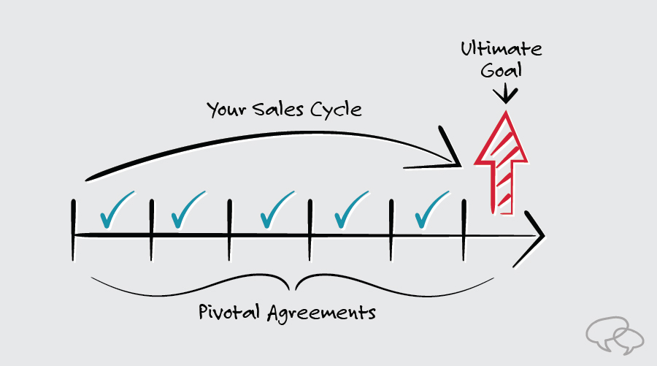
The idea is to proactively decide what you need from the customer during the buying cycle to get the most positive final outcome. In other words, you capture the value and protect your margins by executing a series of Pivotal Agreements throughout the buying process, rather than one grand compromise at the end.
Learn more about Pivotal Agreements in our webinar, There’s an Unlimited Demand for Free.

How to Sell to Existing Customers: Sales Techniques to Expand Value
The sale isn’t over just because your prospect becomes a customer. There’s still ample opportunity to drive growth from customer expansion opportunities like renewals and upsells. Here are three research-backed sales techniques for selling to your existing customers.

Defend Your Customer’s Status Quo
When you’re engaging new prospects, it makes sense to use a provocative, challenging approach that introduces Unconsidered Needs, disrupts their status quo, and persuades them to choose you. As the outsider, you want to frame their current situation as risky and unsafe and introduce your solution as a better, safer alternative.
But when you’re the insider, defending your incumbent position to existing customers, you often need to reinforce your value and highlight the reasons why you’re still the safest choice. Because you are your customer’s status quo, you can use their natural Status Quo Bias to your advantage during renewal and expansion conversations.
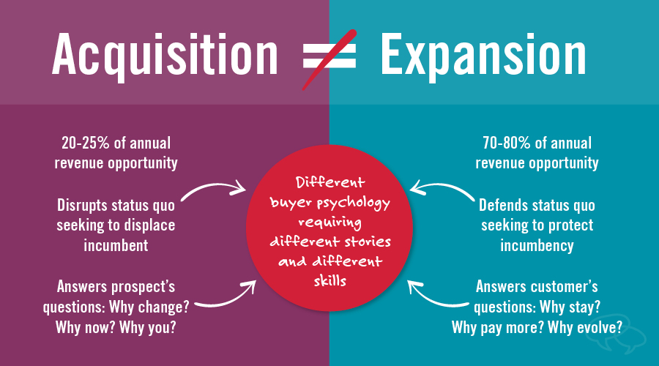
To your existing customers, you are their status quo. And research shows that using a provocative, challenging message when you’re trying to renew or expand business with your customers will increase the likelihood that they’ll shop around by at least 10-16 percent.
Find out when you should (and shouldn’t) defend your buyer’s status quo in our e-book, To Challenge or Not to Challenge.

Upsell by Reinforcing the Relationship
Certain sales conversations with your customers require more finesse than others. Expansion conversations, for example, walk a thin line between persuading your customer to buy more and convincing them to stay with your solution in the process. If you succeed, you lay the groundwork for a long-lasting partnership. But if you stumble, your partnership stagnates, your revenue plateaus, and your customer becomes vulnerable to getting picked off by competitors.
When it comes to winning upsell conversations, our research found that reinforcing the emotional aspects of the customer partnership was most effective in persuading customers to make change seem safe as long as they’re changing with you, not away from you.
In these situations, don’t be afraid to use emotional language to lean into the relationship between you and your customer’s company. Then, leverage that relationship to have a frank conversation about challenges and opportunities befitting a long-term partnership.
Buyers are naturally more inclined to remain with their status quo than change to a new solution. But that doesn’t mean you should take your relationship for granted. Your customers are constantly being pitched by outside vendors who are eager to win their business. Don’t give them the opportunity.

Know How to Apologize
In a perfect world, you would never need to apologize to your customers. But service failures are inevitable. And mishandling these pivotal moments can put your customer relationships, retention, and future revenue at risk. But it doesn’t have to be that way.
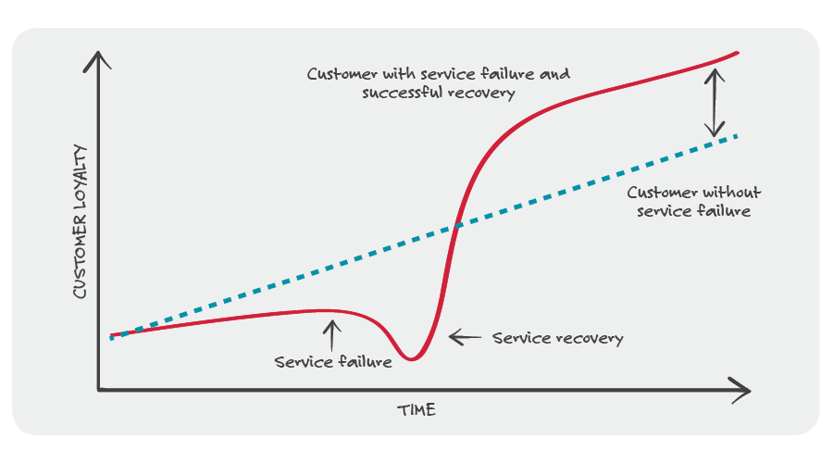
Apologizing to your customers the right way can not only recover the relationship but actually improve their loyalty going forward. Using a concept called the Service Recovery Paradox as a foundation, our research found that a specific apology message framework improved the chances of your customer recommending your product and buying more from you after a service failure.
Learn more about how to effectively apologize to your customers in our State of the Conversation Report, Sorry Shouldn’t Be the Hardest Word.

Sales Techniques that Don’t Work
There’s a lot of “conventional wisdom” for how to sell out there that, in reality, doesn’t actually help you make the sale. Here are four classic go-to selling techniques that may, in fact, be hurting your sales.

Don’t Focus too Early on Selling Benefits
Everyone knows how to sell benefits and not features, right? Well, no. If you start your customer conversation with benefits, you’re jumping the gun when it comes to how most prospects are looking at their first interactions with you and your company.
Remember that up to 60 percent of pipeline deals are lost to the status quo. That means that you need to learn how to sell by establishing a Buying Vision—the case for why the prospect needs to change—before your solution’s benefits will resonate. That means you need to effectively challenge the status quo and show how the prospect’s world can change for the better.

Don’t Compete in a Bake-Off
When you position yourself against your competitors, you’re competing in a vendor bake-off. It’s a “spec war” and you might gain the upper hand with one feature, but then the competition meets your feature and raises another.
In the process, you and your competition are often having a very similar dialogue with the prospect, leading to the dreaded “no decision.” Instead of talking to the prospect about “why us,” focus instead on challenging the status quo by getting the prospect to think about “why change” and “why now,” and demonstrate the truly unique value of your solution.

Don’t Sell to Personas
Many salespeople and marketers use buyer personas to develop messaging. And, on the face of it, it seems to make sense: defining the profile of your prospect will enable you to develop messages targeted to that profile.
The problem is that personas are typically defined by who the prospect is – demographics and behaviors. But the need to change is not driven by a persona. The fact that a prospect shares similar characteristics with the persona isn’t what causes them to re-think their current approach and consider your solution as a new way to solve their problems.
Instead of developing messages based on personas, focus on how to sell by convincing prospects that the status quo they are standing on is “unsafe,” then show them how life is better with your solution.

Don’t Rely on a Standard Elevator Pitch
An elevator pitch is a short summary used to quickly and simply define a product, service, or organization and its value proposition. And just about every sales organization under the sun spends a lot of time trying to perfect that pitch.
The problem is that the standard elevator pitch tells your story—not your prospect’s story. So instead of spending time refining your elevator pitch, focus on building the story that features your customer as the hero and illustrates the unique value you can offer them.

Closing Thoughts on Sales Techniques
There you have it. These 20 selling tips and techniques are proven to help you in all areas of your sales strategy, including prospecting, communicating value, creating urgency, closing the sale, and expanding with existing customers. With these approaches in your arsenal, you’ll be well equipped to handle even the toughest sales conversations.

