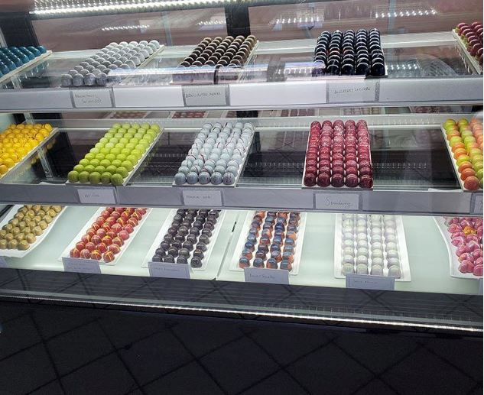  Bonzai Chocolates  Business Plan  (Updated April 2021) | Overview  Bonzai Chocolates is a high-end chocolate confectionery shop dedicated to quality creations and passionate about bringing the finest flavors to every of our valued customers. This is a business plan to cover the 2021-23 time period.

Executive Summary

Bonzai Chocolates is woman-owned LLC established by a sole proprietor, LaQuisha McDonald, in 2019. LaQuisha is a certified Master Chocolatier. She is assisted by her husband Donald, who manages financial and accounting aspects of the business and advises LaQuisha on business strategy. The company specializes in the production of luxury, artisan chocolate confections using natural, fair trade ingredients. Its primary products include assortments of bonbons, dipped fruit orange peels, mendiants, peanut butter cups, and chocolate pecan turtles. Each item produced is a high quality handmade work of art. Bonzai is based in a retail location in a shopping plaza in Mishawaka, Indiana where all production is also done. Sales are through the store, the company website, and through other retail stores. While most revenue has come from in-store sales, Bonzai is attempting to move towards a predominately on-line model supplemented by store and other sales. The market includes the greater Michiana area. The company seeks a stable, steady growth model. Bonzai Chocolates sells to both business and consumer clients, with the b-to-c market represented the larger proportion of revenues. Sales tend to spike during the Christmas season and around Valentine’s Day and Mother’s Day. To market its products, Bonzai relies upon its website, social media channels, personal selling, networking, and word of mouth. Operations center on a hand-made production process that includes six stages and requires most of a week. The top selling product, bonbons, has a three-week shelf life. At current prices, the breakeven sales level is just over 14,500 pieces of chocolate per year. Financial performance for 2020, the first full year of operation, included total revenue of $48985, and a profit of $2,604 was realized. Gross margins approximate 80%. Revenue is projected to grow to $65,199 with profits of $13,105 in 2023. These numbers can be accelerated if production capacity can be expanded without compromising product quality. Toward this end, Bonzai is seeking a loan for $25,000 to purchase production equipment.

The Artisan Chocolate Industry

Bonzai Chocolates operates in the chocolate and confectionary manufacturing and retailing industry (NAICS code 311351, UNSPC codes 50161511 and 50161813). The global chocolate confectionery market size was valued at USD 114.33 billion in 2019 and is projected to reach USD 136.42 billion by 2027, exhibiting a compound annual growth rate of 2.31% during this period. The global per capita consumption of chocolate currently equals about 0.9 kg per year.

Of particular note is the impressive demand for premium chocolates, a segment that is experiencing growth across the globe due to rising consumer discretionary income and an expanding gifting market. Consumers are looking for novel chocolate flavors and innovative chocolate formulations, which fuels segment growth. Moreover, the increased importance of seasonal chocolates during special events and their increased affordability is also contributing to market growth.

While Europe is the largest market for chocolate products in general, North America is the largest market for premium chocolate confectioneries (see table below). This rapid escalation in demand for premium or specialty chocolates in developed markets is expected to continue in the foreseeable future. The COVID-19 induced global economic shutdown saw an initial rise in demand due to consumer stockpiling behavior, but subsequently, production and sales of chocolate items have experienced a slump (U.S. Department of Agriculture). COVID-19 has also resulted in a disruption of the supply chains including the movement of raw materials from the producing countries to the consuming countries. The same is projected to affect the market as it may lead to higher costs to the chocolate manufacturers and increased cost of end products. Sales have recently begun to pick up and are expected to fully rebound following the pandemic.

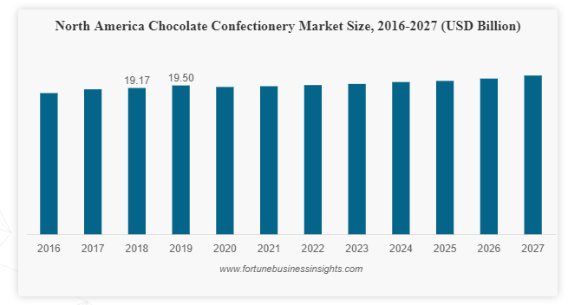
A number of factors explain the longer-term growth pattern, particularly for specialty chocolates. The market is being driven by evolving preferences for novel and innovative confectionery products. Consumers are looking for healthy products that also provide indulgence. There is growing popularity of dark chocolate, which is attributed to the increasing knowledge regarding the health and wellness benefits of cocoa. Fitness concerns have stimulated demand for sugar-free chocolate snacks with higher cocoa content. Customers also seek the stress relieving characteristics of chocolate. The rising consumer trends toward organic, clean label, and sustainably sourced chocolate have fueled sales and encouraged extensive new product development. In addition, attractive packaging solutions (both design and package size) and enticing sensorial appeal are contributing to market growth. A heightened consumer desire to know the origin of ingredients used in chocolate confectioneries due to safety concerns is expected to further foster the growth of specialty chocolates. An increasing concern for issues surrounding labor welfare is also expected to fuel the demand for fair-trade chocolate in the coming years.

Premium and specialty chocolate products are finding increased seasonal and holiday demand. In the U.S., demand tends to spike at Christmas, Easter, Valentine’s Day and Mother’s Day. At the same, these products are increasing purchased as gifts when consumers travel and during festival celebrations and religious events. Their use as gifts by corporate and other organizations is also on the rise.

In terms of detracting factors, the increasing prevalence of lifestyle-related health conditions such as obesity and diabetes associated with excessive sugar consumption also have implications for the chocolate industry. It is estimated that 415 million people had diabetes in 2018 across the world and this is expected to grow to 642 million people by 2040. Diabetic patients resist the consumption of chocolates to avoid and reduce sugar intake in their daily diet.

The industry has a mixed structure, with a number of very large players playing a dominant role, particularly in the mainstream chocolate market. Examples include the Hershey Company and Nestle. Hershey had sales of USD 2.037 billion in the first quarter of 2020 which is an increase of 1% compared to the same period a year ago (2.2% in North America). At the same time, recent years have witnessed significant growth in the number of small, niche players selling high-end specialty chocolates. A set of notable examples in the so-called artisan or craft segment, where Bonzai competes, are provided below:

French Broad Chocolates: Based in Asheville, NC this husband and wife team started in Costa Rica with a small café, but after some success moved to Ashville, where they grew grown into one of the finest bean-to-bar chocolate companies in the country. Their products are sold at their chocolate lounge.
Mast Brothers: Based in Brooklyn, NY, these two brothers are pioneers in the bean-to-bar movement, starting from raw beans, roasting them, and being involved in every moment of the chocolate-making process. Everything including packaging is done by hand.
Vosges: Started in 1997 and based in Chicago, Vosges makes chocolate bars and truffles that are as pretty to the eye as they are delicious to the taste. The chocolates are inspired by the vibrant flavors and experiences of life and travel and orders can include a bottle of wine.
Jacques Torres: With a background as a pastry chef, Torres creates culinary works of art, using his favorite ingredients, including fiery chili pepper. Even with rapid growth, this New York-based company continues to make each ingredient from scratch.
Theo Chocolate: Based in Seattle, Theo stresses premium quality together with protecting the environment. They use only organic, fair trade and GMO-free ingredients in their products. They also offer classes to teach customers about chocolate-making techniques and methods.
Rogue Chocolatier: Based out of a small Massachusetts town, and viewed as an emerging leader after just ten years, Rogue focuses on simplicity and old style handmade techniques that allow the true flavors and subtle notes of the chocolate to shine through. They use just cocoa and sugar, and no cocoa butter, resulting in honest and uncomplicated products.
Amano: Located 40 milies south of Salt Lake City, the company launched 10 years ago, seeking to focus on excellence in terms of the origins, harvesting, roasting, and preparing of chocolate. Their cocoa comes from Ecuador, Dominican Republic, Peru, Papua New Guinea, among others.
Patric Chocolate: Launched in 2006, the company has received accolades from the likes of Gourmet Magazine, Food and Wine Magazine, and the Good Food Awards. They make chocolate bars with an emphasis on quality, craftsmanship, and sustainability, and produce unique flavors (e.g., raspberry-balsamic pear, black licorice, and red coconut curry) The company works with key organizations (Slow Food Nation, Craft Chocolate Makers of America) to foster chocolate education.
Chocolopolis: Based in Seattle, instead of bean-to-bar production, they focus on curating a collection of craft chocolate from all over the world. They make decadent drinking chocolates, creative bars, and gorgeous confections, and attempt such combinations as the dark orchard bar: hazelnuts, dried cherries, dried blueberries, vanilla sea salt, and dark chocolate.
Castronovo Chocolate: Based in coastal Florida, the business stresses depth of flavor and discovering the natural integrity of the chocolate. Their key is to slow down and savor the process of making chocolate, allowing the essence of the beans to shine through. They offer award-winning single-origin bars, truffles, and seasonal chocolates.
Askinosie Chocolate: A family-owned business from Springfield, Missouri, Askinosie is dedicated to kindness and community. They buy direct from farmers in a program called Chocolate University, and work with local school children in the art of chocolate making, Products include bars, nibs, cocoa powder, chocolate beverages, and a chocolate hazelnut spread.

From an industry attractiveness standpoint, the industry has medium to low entry barriers, fewer effective substitutes for the high-end portion of the market, moderate bargaining power of suppliers, lower bargaining power of consumers, and growing competitive intensity.

- Company, Concept and Products

Company Details

Name: | Bonzai Chocolates
Location: | 2454 Wandering Lane,  South Bend, IN 46617
Phone Number: | 574-208-8441
Email: | Bonzai@Bonzaichocolates.com
Website: | Bonzaichocolates.com
Legal Status: | limited liability company
DUNS Number: 095355818
Restaurant License: 6739222
Indiana Retail Merchant Certificate TID: 019638211
St. Joseph Department of Health Permit: 18-1342
Indiana Dept of Admin Bidder ID: 00000930422
Buy Indiana Status: Category # IC 5‐22‐15‐26.5

Bonzai Chocolates is a woman-owned, limited liability company based in South Bend, Indiana that manufactures premium chocolate products from raw chocolate. The company has a food service permit with a restaurant license. Bonzai is co-owned by LaQuisha McDonald—51% equity and Donald McDonald—49% equity. The co-owners are hardworking and responsible owners. The duo is in charge of company operations with LaQuisha McDonald as President and Donald McDonald as Vice-President.

Vision and Mission Statement

As a chocolatier, Bonzai Chocolates strives to be a beacon of light in the Michiana community, the perfect vehicle for celebrating life’s little moments by enjoying the simple pleasures of wholesome goodness. Customers will experience high quality chocolate confections in friendly and pleasant atmosphere. As a game changer in the chocolate industry, Bonzai Chocolates seeks to make customers aware of the health benefits and beauty of chocolate that is made from fresh & natural ingredients without preservatives. The company endeavors to nourish the body, soul, and spirit of our customers by providing quality chocolates, wholly made with care and expertise, bringing people from diverse cultures and interests together through high-quality chocolate and desserts.

Unique Value Proposition

Bonzai is an artisan chocolatier that sells indulgent experiences that are tastier, healthier, all-natural and ethically sourced.

We accomplish this value proposition through:

- commitment to natural, local, sustainable ingredients for freshness and quality
- 100% fair trade, organic cocoa
- ethically sourced ingredients
- unique flavors inspired by various exotic regions
- all natural, peanut-free, and glutten-free chocolate
- gluten free, dairy free, nut free, vegan dark chocolate
- 100% natural fruit, sun dried with lemon juice with no additives, preservatives, colorants, or added sugar
- 100% natural premium chocolate confections free of additives
- commitment to freshness means all prepared bonbons, confections, and chocolates have a shelf of life of up to three weeks to ensure quality
- delivery and pick-up available
- 24/7 customer support

Business Model Canvas

Below is the essence of the Bonzai business model using the business model canvas:
PROBLEM | SOLUTION | UNIQUE VALUE PROPOSITION | COMPETITVE EDGE | CUSTOMER SEGMENTS
Available high quality chocolates in the defined market include preservatives and are not nut-free or gluten-free | Bonzai Chocolates products provide a healthier and higher quality alternative for those who seek a healthier life and love sweets | Bonzai Chocolates are customized works of art, with superior taste and freshness, while having no preservatives, and relying of fair trade ingredients. | Strong credentials and certification on mastery of chocolates with the best chef and chocolatiers in the industry | - Hotels/bed & breakfast locations  - Hospitals  - Schools  - Companies  - The general public in Mishawaka, South Bend, Granger, Notre Dame and Elkhart
 | KEY METRICS  - Conversions  - Bounce Rate  - Customer Satisfaction  - Visits/Sessions |  | CHANNELS  - Retail store  - Company website (online sales)  - Sales through other retailers
Cost Structure  - Production cost  - Customer acquisition cost  - Rent  - Hosting |  | Revenue Streams  Revenue Model: Direct sales, store sales and web sales

Business Objectives

Over the next five years, Bonzai Chocolates seeks to:

- establish a solid foundation for sustainable business growth;
- run a profitable business by steadily increasing revenue while limiting expenses;
- provide the best chocolates available in well-furnished brick and mortar stores in premium areas with high customer traffic;
- become the chocolate destination of choice for families, individuals, friends, and tourists in the Michiana area;
- maintain the functionality and beauty of the store in a manner that exceeds customer expectations to encourage repeat business;s
- maintain excellent customer relationships that result in consistent repeat business and positive word of mouth;
- continuously improve production and administrative operations with state-of-the art equipment and process technologies;
- be a good corporate citizen, contributing where possible to the welfare of the community, and promoting environmental awareness and fair trade practices.

Product Mix

Bonzai’s core competencies center on chocolate tempering, molding and sculpting. Our products represent exquisite chocolate creations with the finest and richest flavor combinations. Bonzai Chocolates offers superior quality chocolate and desserts for on-premises cafes, events, promotions, and more. Our five primary product categories include:

- BonBons (sold in packages of 6, 9, 16 or 25) and available in the following flavors:

- cardamom coffee
- ethiopian coffee
- berry blast
- mexican vanilla
- pepita pistachio
- coconut bliss
- yuzu caramel
- mango passion caramel
- raspberry thyme caramel
- tropics
- dulce de leche
- brown butter

- Dipped Fruit Orange Peels

- Mendiants (Healthy Bites):

- Milk Chocolate
- Dark Chocolate
- Pecan Galore
- Berry Mix
- Almond Toffee
- Omega-3

- Peanut Butter Cups (4-piece and 6-piece)

- Chocolate Pecan Turtles (2-piece and 6-piece)

We also sell e-gift cards in any dollar amount for all of the products above. Product innovation is an ongoing activity as we continually develop both new products and new flavors in response to both industry trends and customer preferences.

- The Market

Market Definition and Size

The relevant market for Bonzai Chocolates can be defined as Michiana—a region of northern Indiana and southwestern Michigan centered on the city of South Bend, Indiana. According to the St. Joseph County Chamber of Commerce, Michiana includes St. Joseph County and counties contributing 500 inbound commuting workers to St. Joseph County daily. These counties include Elkhart, La Porte, Marshall, and Starke in Indiana, and Berrien and Cass in Michigan. Based on the 2010 census, the population of all seven counties total 856,377 people (647,271 in Indiana and 209,106 in Michigan).

When looking at the chocolate industry within the Michiana market, our focus in on the demand for artisan or craft (higher end) chocolate and specialty cacao. Currently, the industry lacks a clear definition of craft chocolate, standards for defining specialty and fine cacao, and differentiation between the premium chocolate sector. Nonetheless, publicly accessible data shows that candy and chocolate make up a significant segment of the food industry in the State of Indiana. Within the region, candy and chocolate generates $1 billion/year. Chocolate makes up 67% of the candy industry, resulting in $670 million in sales in the State of Indiana. Fine chocolate makes up 33.8% (IBIS World Graph) of this industry, or approximately $226,460,000 in annual sales. (see below for a breakdown of chocolate sales). Considering the Michiana population as a percentage of statewide chocolate revenue, we can estimate a local market size of about $28.9 million.

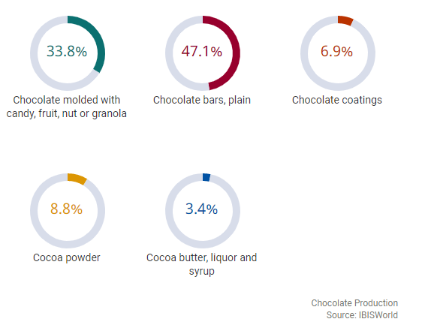

Buyer Descriptors

The market for high end chocolates in Michiana includes both business-to-consumer (B-to-C) and business to business (B-to-B) customers. In general, about 65% of chocolate sales are on the B-to-C side, and this pattern holds true for Bonzai Chocolates. More specifically, Bonzai find that B-to-C sales tend to spike around Christmas, Valentine’s Day and Mother’s Day, while B-to-B sales are more level across the year and so can sustain the business during non-peak months.

Demographic information is important to consider when evaluating B to C customers. Key demographics are listed below:

- 30% male and 70% female
- 20% minority and 80% white
- 30% low/middle income (<$75k) and 70% high income (>$75k)

With respect to the B-to-C marketing, the company had over 600 unique customer transactions from January-December 2020. Given its geographic area, customers primarily consist of a middle-age to older demographic, interested in purchasing specialty chocolate for a special occasion, event or gift. The customers overwhelmingly come from the greater Mishawaka area (over 95%).

Currently, Bonzai’s B-to-B customers include:

- Notre Dame University - Notre Dame, IN (Scope of work: 30 boxes of bonbons)
- Ivy Tech Community College - South Bend, IN (Scope of work: 150 boxes of bonbons)
- Atlantic Aviation - South Bend, IN (Scope of work: 20 boxes of bonbons)
- Write Connections - Elkhart, IN (Scope of work: 75 boxes of hot chocolate bombs)
- Effect Web Agency - Granger, IN (Scope of work: 40 boxes of bonbons)
- Majority Builders, Inc- South Bend, IN (Scope of work: 70 boxes of bonbons, 70 boxes of turtles)
- Ten Thousand Villages Store (Nonprofit) - Granger, IN (Scope of work: carry our product in the store and provide collaboration and support)
- Take Care South Bend (mails gift boxes to clients) (Nonprofit) - South Bend, IN (Scope of work: feature our products in their gift boxes and provide collaboration and support

Buyer Behavior

Among B-to-B customers, most purchases are made for special events or holidays. These one-time large purchases are fairly predictable as they are called-in ahead of time. For businesses, this is a medium involvement purchase and they typically have a pre-defined need. They are attempting to purchase higher end or specialty chocolates for employee and client celebrations and gifts. The key is personal contact between Bonzai and the organization in question, and particularly with the key decision-maker within the organization. Periodic follow up with these accounts is critical, as once they purchase, follow-on purchases are likely.

When looking at the B-to-C market, purchases are made year-around. Consumers view artisan chocolate as a medium involvement purchase given the price and options available. While for some it is an impulse purchase, most buyers are looking for a higher quality chocolate product based on being chocolate aficionados, foodies, or seekers of a quality gift from someone special. Bonzai Chocolate revenues are higher in first and last quarter of each year. The highest number of visitors support Bonzai Chocolates between February and March. Each year, higher sales activity is cyclic corresponding with sales spikes at Christmas, Valentine’s Day and Mother’s Day. When looking at the breakdown of first, second, and third time customers, most are first time customers. In 2020, there were approximately 500 unique first time customers, 90 two-time customers, and 60 three-time customers. Many customers have a positive relationship with Bonzai’s owners causing them to return for chocolate. Nonetheless, overall, the purchase still primarily transactional versus relational as chocolate is a food product.

When looking at online traffic, much of it comes from interested customers in Michiana. Last year, the day with the most online traffic was December 5th, consisting of 1,879 site views. Online viewers will typically search Bonzai Chocolates, view the home page, and explore the bon bon page. All in all, when looking at in-store sales and online sales, 80% has been in-store while the remaining 20% occurs through the website and social media channels.

Below is a simple model that captures our customer’s buying process:

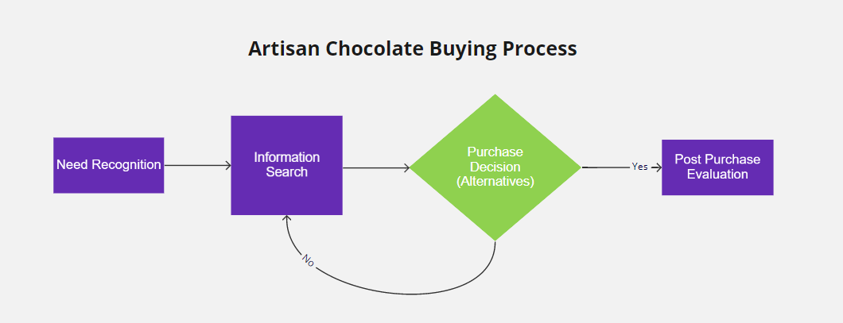

Need Recognition

Need is strongly perceived based on consumer type. For the chocolate aficionado, need is high and ongoing as this is part of their interest and purchase patterns. For the gift giver, need is time sensitive and tied to an event or occasion necessitating a gift. With artisan chocolate, consumers are attracted to stimuli such as colorful or uniquely designed chocolate products in glass cases, products near registers at stores, and brightly colored packaging. Advertisements may also play a role. The product typically sells itself based on design, quality, and taste.

Information Search
The three most prominent means of learning about chocolate providers including happening upon the store and walking in, online searches, and word-of-mouth. Many consumers find information online through search engines such as Google, Bing, and Yahoo, which allow users to quickly names of local artisan chocolatiers, stores that carry their products, and various products available online. The prospective customer will visit the provider’s Facebook business page or their website, where there is an opportunity to provide education and information regarding one’s product selection, quality, ingredients and their sources, and the chocolate making process, together with information on store location or the online ordering process, pricing, delivery and customer service. With store visits, store displays and menus highlight chocolate products allowing consumers to see all their options in front of them. Packaging also states what type of chocolate is offered whether its milk chocolate or special dark chocolate. To add, consumers waiting in line often ask others about the chocolate or simply ask the cashier for more information.

Evaluation of alternatives and purchase
There are a limited number of artisan chocolatiers in most cities (roughly 3 per 100,000 people). The buyer is willing to pay more and invest a bit more effort in finding a superior chocolate product. The purchase decision tends to be driven by an assessment of the following attributes, with customer’s varying in the relative weights they put on a given attribute:
- Product appearance and display
- Product taste
- Chocolate expertise of the seller
- Product variety or options
- Product packaging
- Price points for different quantities
- Store environment

While differentiation from standard chocolate products available in grocery stores, pharmacies and discount stores is relative easy, customers may have more difficulty choosing among artisan chocolate providers, as many of them make similar claims. Taste and elegantly designed chocolates become especially critical deciding factors.
Post purchase behavior
Once they have purchased the product, customers become a critical source of repeat purchases and/or positive word of mouth. If purchased for themselves, customers evaluate their experience based principally on taste and the reactions of others with whom they share the chocolates. If purchased a gift, the buyer may or may not get any specific feedback on satisfaction with the product. Positive feedback incentivizes the buyer to make future gift purchases for others from the same chocolatier. One challenge is the extent to which the recipient of chocolate as a gift becomes familiar with the source and contact information of the chocolatier. Hence, packaging becomes critical not just for establishing an image but for conveying critical information that makes it easy for the gift recipient to make their own follow-on purchases.

Market Segmentation

Below is a segmentation tree breaking down the Michiana market into specific types or groups of customers to be targeted. The most critical distinction is between the business-to-business and business-to-consumer segments. However, each of these can be further broken down. Within the business segment, key organizations purchasing artisan chocolates tend to include:

- Hotel and hospitality industry
- Wedding and event planners
- Higher educational institutions
- Holiday gifting firms
- Mid-sized and larger companies hosting events for employees, customers, other stakeholders

The decision-maker varies depending upon the type of organization. For instance, with hotels and hospitality companies, the decision-maker may be a marketing or events manager, while with wedding or event planners as well as event gifting companies, it is typically the president of the company. While most of these organizations can purchase flexibly from companies like Bonzai when they have a need, with education institutions the provider may need to be an approved vendor. Personal selling is necessary to initially penetrate these accounts, coupled with periodic follow up. Once satisfied with a purchase, these organizations are likely to periodically re-order over the phone or through a website order.

There is also an opportunity to sell to retail businesses for resale to final customers. Bonzai has had limited experience with placing product in other stores because of the focus on building up its own store traffic. However, a relatively large order placed by Ten Thousand Villages, a fair trade store in Mishawaka was sold out in a very short period of time. While margins are smaller on such sales, the potential for good volumes suggests significant potential to make more money through other retailers.

With the B-to-C market, the key segments are those buying for themselves and their families, and those purchasing chocolate as a gift for someone else. Gender would appear to be an important variable for further segmentation of both of these groups. With gift giving, particularly at the three peak holiday periods, men represent the larger segment. Alternatively, with purchases for the household, women may be the larger segment. Income is also a salient segmentation variable, with middle and higher income segments, with the largest potential coming from those with family incomes exceeding $100,000 per year.

Competition

In the South Bend area, there are four chocolate makers. They include:

- Bonzai Chocolates
- Davis Chocolate: As a bean-to-bar chocolate manufacturer, Brent Davis has traveled around the world to many chocolate farms—including Ecuador, Hawaii, and the Dominican Republic—in search of the best beans. He favors the flavor of Ecuadorian beans, which are organic and fair trade-certified.
- Violet Sky American Craft Chocolate: Violet Sky sells bars of chocolate sourced from Africa and South America. Its primary location is in South Bend, with partnering locations around the city. Products are also sold at several online stores.
- The South Bend Chocolate Company: The South Bend Chocolate Company has 11 company-owned stores in Northern Indiana and 4 franchise locations throughout Indiana, Michigan, and Ohio. Confections roll out of the factory each day. Twenty-five years after its founding, the company produces over 500 different chocolates and sweets. These products are available in stores nationwide and at company owned stores.

Nationally, there are a growing number of artisan chocolate companies and many of these offer on-line sales and can ship product to customers in the Michiana area. Examples of some of the leading firms that ship anywhere include:

Phillip Ashley Chocolates: Memphis, TN https://phillipashleychocolates.com/
Garcia Nevett: Miami, FL https://garcianevett.com/
Chocolat Uzma: Chicago, IL https://www.chocolat-uzma.com/
Kreuther Chocolate: New York, NY https://kreutherchocolate.com/
Christopher Elbow: Kansas City & San Francisco, CA, https://www.elbowchocolates.com/
Stick with Me: New York City, NY https://swmsweets.com/
French Broad Chocolates: Asheville, NC https://www.frenchbroadchocolates.com/
Compartes: Los Angeles, CA, https://compartes.com/
Cocoa Belle Chocolates: Bryant, AR, https://cocoabellechocolates.com/
Harlem Chocolate Factory: New York, NY, https://harlemchocolatefactory.com/

In addition, some of these providers will make their products available for higher end retail stores in the South Bend areas to re-sell.

Beyond this, boxed candy products from such providers as Ghirardelli, Godiva, Lindt, Whitman’s, SEE’s and Russell Stover are available are a wide range of gift, specialty, discount, department grocery, and pharmacy stores in the region. While these companies sell regular chocolate products such as bars, truffles, and dips, they do not offer the artistic design, quality ingredients or craft production processes available from artisan providers such as Bonzai.

Competitive Edge

Our competitive edge lies in our quality services and the competence of our staff. We are ahead of our contemporaries in the industry due to our ability to focus on producing chocolates that are gluten-free and nut-free with no preservatives. In addition, as a local business, there is a compelling story behind Bonzai that can resonate with local customers.

Sales Projections

Bonzai Chocolates sales projections are based on consumer demand and buying behavior assumptions, and intended marketing efforts for the Michiana market. Our goal is steady, stable growth, not rapid expansion. The conservative expectation is that sales will grow year-over-year by approximately 10 percent (see below). These are projections assuming no loan or investment in improved equipment and production capacity. The evidence suggests sales could grow faster is capacity were expanded.

Category | 2020 | 2021 | 2022 | 2023
Sales | $48,985 | $53,884 | $59,272 | $65,199
Profit After Breakeven | $2,604 | $10,831 | $11,914 | $13,105

Economics of the Business

Costs, Margins and Breakeven
Bonzai has six revenue drivers. Bonbons represent 64% of total sales (80% of our manufactured chocolate product sales), turtles are 6.6% of sales, mendiants are 6% of sales, peanut butter cups are 2.4% of sales, and chocolate dipped fruits are 1% of sales. The other 20% is revenue from hot chocolate mix (that we sometimes sell when raw material is available) and an assortment of other products sourced from outside providers and resold. Prices for the internally manufactured items range from $1.18 per unit for chocolate dipped fruits (sold in package of 11) to $3.50 per piece for turtles. An average price of $10 is used for the mix of externally sourced items. Variable costs include ingredients, labor and packaging costs. As summarized in the table below, the margins on all five revenue drivers are favorable, ranging as high on a percentage basis as .84 and .89 on turtles and peanut butter cups, respectively. The major profit contributor is the bonbons, constituting the biggest proportion of sales with a contribution margin percentage of .64.

Product | Bonbons | Chocolate Dipped  Fruit | Mendiants | Peanut Butter  Cups | Turtles | Other  (hot chocolate, sourced products)
Price per piece | $2.50 | $1.18 | $2.50 | $2.25 | $3.50 | $9 (average)
Variable cost per  unit | $.90 | $.36 | $.60 | $.25 | $.55 | $7.00
Contribution  margin | $1.60 | $.82 | $1.90 | $2.00 | $2.95 | $2.00
Contribution margin as a  percentage (PVCM) | .64 | .69 | .76 | .88 | .84 | .22
% of total sales accounted  for by product | 64% | 1% | 6% | 2.4% | 6.6% | 20%
Note: sold in
packages of 11; numbers
here are per unit

Based on calendar year 2020, total fixed costs are equal to $26,950 annually. As summarized below, the key fixed costs include:

Fixed Cost Category | Amount
Advertising and marketing | $3,241
Rent | $3,000
Insurance | $208
Bank charges and fees | $229
Fees for professional services | $302
Meals and entertainment | $1,297
Office supplies, software fees | $8,242
Repairs and maintenance | $949
Employee for counter/cash register | $3,202
Square fees | $1,228
Job supplies (adjusted) | $3,362
Other miscellaneous fixed costs | $1,190
Total fixed costs per year | $26,450

To calculate breakeven, we have estimated a weighted average contribution margin. In essence, we weighted the contribution margins of each product line or revenue driver based on its percentage of total sales. This produced a weighted contribution margin per unit of $1.81.

The weighted average contribution margin was then divided in total fixed costs, producing a breakeven number (in units) of:

$26,450 = 14,613 units (pieces)
$1.81

These units are distributed across the product mix. Based on the percentage of units (not sales revenue) that each product currently represents, and using bonbons as an example, the company needs to sell 10667 units of bonbons annually to breakeven, and in 2020 a total of 11,974 units of bonbons were actually sold. Total production of all items in 2020 was 16,346 pieces, resulting in a marginal profit in this first year. The projected breakeven chart below illustrates the potential for significant profit growth in the next few years.

Break-Even Curve Over Five Years

Profit Model

The profit model at BONZAI reflects the logic of how profits are earned by the company by considering margins, volumes, operating leverage and revenue drivers. At present, the company operates with moderate margins on low to moderate volumes. Volumes in 2020 were enough to achieve breakeven and generate a small profit, suggesting profits will continue to rise as the customer based grows and more systematic and targeted marketing efforts are implemented. Fixed costs currently represent about three-fourths of all expenses, suggesting high operating leverage. However, some of these costs will come down as the first year of operations involved considerable learning and some inefficiencies. Further, some of these costs have been eliminated for the immediate term, such as the hourly employee. And, with more precise tracking and enhanced ordering, the job supplies are likely to become largely variable costs. Finally, BONZAI has six revenue drivers. Of these, bonbons are clearly the top contributors to profitability, followed by turtles and mendicants, Chocolate dipped fruit is a candidate for deletion, although it may offer some marketing benefits insofar as it contributes to an image of a diverse mix of high end products. The key question going forward is the role of the externally sourced products. These would seem to be more of a distraction, taking time and money away from the company’s production of artisan chocolates, and the intention is to discontinue these items. The exception being hot chocolate mix. Here, product sells out quickly, and decent margins are earned, but supply of the key ingredient can be problematic. BONZAI will continue to work on a more dependable supply arrangement for hot chocolate.

- Marketing Plan
Overall Marketing Strategy

Bonzai Chocolates is positioned as a locally-based but internationally-experienced provider of uniquely designed and hand-made artisan chocolates at a reasonable price. Our tagline is “Where Chocolate Meets Art.” We are selling indulgent experiences that are tastier, healthier, all-natural and ethically sourced. The company and its offerings are differentiated on five key bases:

- a commitment to natural, local, sustainable ingredients for freshness and quality, using 100% fair trade, organic cocoa
- unique flavors inspired by various exotic regions
- all natural, peanut-free, gluten-free, dairy free, and vegan chocolate
- 100% natural fruit, sun dried with lemon juice with no additives, preservatives, colorants, or added sugar and100% natural premium chocolate confections free of additives
- Product freshness: all bonbons, confections, and chocolates have a shelf of life of up to three weeks to ensure quality

Our overall marketing efforts center around a mix of social media communications, personal calls on businesses, social networking in the community, and in-store promotions. These efforts are further elaborated upon in the sections that follow our pricing discussion below.

Pricing Approach

Bonzai’s pricing challenge is to use price to convey the superior nature of our product offerings, while also reflecting a target audience in South Bend that will pay for quality but may resist a truly premium price. As such, we are pricing at parity with other artisan chocolatiers in the region. Below is a summary of the company’s current pricing structure:

Bonbons | Peanut Butter Cups | Mendiants (Health Bites)
6 Bonbons: $15.99  9 Bonbons: $21.99  16 Bonbons: $35.99  25 Bonbons: $53.99 | 4-Piece Peanut Butter Cups: $8.99  6-Piece Peanut Butter Cups: $12.99 | Milk Chocolate: $14.99  Dark Chocolate: $14.99  Pecan Galore: $12.99  Berry Mix: $12.99  Almond Toffee: $12.99  Omega-3: $12.99
Dipped Fruits | Turtles: | E-Gift Cards:
Orange Peels: $12.99 | 2-Piece Choc. Pecan Turtles: $7.00  6-Piece Choc. Pecan Turtles: $21.00 | Any Amount

Promotional Approach

Bonzai has organized its promotional efforts around a three-stage selling process (see below). It starts with awareness creation. We want widespread awareness of the Bonzai name within the Michiana region. Awareness will be stimulated by a mix of activities that center on social media messaging, boosted posts, driving people to the Bonzai website, attending social networking events, and engaging in some co-marketing efforts with others firms involved in complementary activities. The website can be found at https://Bonzaichocolates.com/ and the Facebook business page can be found at https://www.facebook.com/Bonzai.Chocolates/. Bonzai’s other social media presence includes Instagram (Bonzai.Chocolates) and Twitter (Bonzaichocolates). The Bonzai website and Facebook page pop up quickly and near the top when doing a Google search of chocolate in South Bend, but there are additional efforts we will engage in to foster search engine optimization.

Bonzai Marketing Communications Process

Once someone is aware of Bonzai, our challenge is to create preference and get them to buy. Critical promotional tools here include our website (and an informational video on the site), in-store salesmanship and displays, and special sales promotions around holidays. As we build a following on the Bonzai Facebook page, we will initiate periodic blogs about interesting aspects of the chocolate making process, our fair trade practices, and other information that helps prospective clients understand why our products are superior and the customer benefits associated with our products.

The third stage in our communications process involves building the customer relationship. Here the focus is on generating repeat business and encouraging positive word of mouth. Our goal is to achieve a 50% customer reorder rate. Success here is dependent upon building trust with customers in the quality and consistency of our products, our product availability and delivery, and our client interactions. In addition, regular follow up email and Facebook communications with customers, particularly around the key holidays when sales tend to spike. In addition, offer special discounts to loyal customers in conjunction with these holidays. Separately, with the b-to-b market, follow up sales calls are made where we leave product samples with key decision-makers. Efforts are ongoing to build the Bonzai customer database in order to facilitate these efforts, and to populate with additional data on customers as we learn more about them. It is hoped that we can integrate a customer relationship management (CRM) software product such as Constant Contact within the next year.

Distribution Approach

Bonzai distributes its products through three channels. The primary channel has been a strorefront at 2454 Wandering Lane, South Bend, Indiana. This is a standalone building located near a major retail district and intersection of two major roads. While the greatest volume of sales has been through the store, the strategic intention over the next two years is to generate a majority of sales online through the Bonzai website. The third channel is sales to businesses (such as the University of Notre Dame) and through other retailers (such as Purple Porch). Not much effort has been expended on this opportunity but this will receive greater focus as Bonzai moves forward.

Customer Service

As the Bonzai products have a relatively short shelf life the company works hard to ensure dated products are not available to customers. In addition, products cannot be exposed to hot conditions, and this is reflected in the company’s shipping and delivery policies. If product quality received by a customer is compromised in any way due to Bonzai’s production and distribution approaches, the company will replace the customer’s order with no questions.

- Operations Plan

All company operations are conducted in the retail location where Bonzai Chocolates is based, The operations plan for Bonzai consists of four key components—sourcing, the production process, quality control, and operational capacity (and associated equipment owned).
Sourcing

Bonzai Chocolates uses Guittard for its primary sourcing needs. Guittard uses superior, shade-grown cacao because the delicate pods are protected from excessive direct sunlight during development. This practice also preserves the jungle environment surrounding the crops. Guittard uses local farmers in Africa, and harvests cacao beans year-round, but primarily from October through March. Although more labor intensive, frequent harvesting ensures that each cacao pod reaches optimal ripeness before being picked. When harvesting, the growers open the pods to take out the beans, which are covered in a white, very sweet pulp. Once the beans are removed, farmers ferment the beans, usually in wooden boxes covered with banana leaves, for three to five days. Specific fermentation methods are used to develop preferred flavor characteristics. Finally, growers spread the beans out to dry naturally in the sun, sometimes using a rake as part of their traditional, carefully crafted drying patterns. Sun-drying enhances natural chocolate flavor and avoids pitfalls associated with other methods. Guittard chocolate is made almost exclusively of sun-dried beans.

Once the beans are shipped to the United States, Guittard, roasts, winnows, and grinds the beans into a chocolate liquid. At this stage, other ingredients, such as sugar, cocoa butter, and milk (in the case of milk chocolate) can be added. The resulting thick chocolate is taken from the mixer and refined further to an extremely smooth consistency. Conching is the crucial next step in flavor development, where nuances and complexities are created in the chocolate. Last, the chocolate is tempered to achieve consistency and moulded into bars, wafers, and chips.

The Production Process
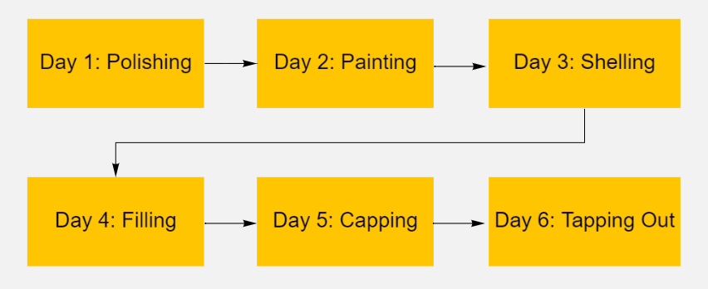

As illustrated above, the process employed by Bonzai involves six primary steps:

Day 1: Polishing—to create shiny finished bonbons: After washing Bonzai’s chocolate molds, each cavity must be buffed with cotton pads until it sparkles, to achieve the perfect shine.

Day 2: Painting—to express the flavor of the bonbon using color: Bonzai paints layers of different colors of cocoa butter into the mold cavities to create abstract designs. Painting each cavity by hand creates a unique work of art each time.

Day 3: Shelling-to create a hollow thin shell: Bonzai pours tempered chocolate directly onto the painted mold which is then inverted to create a hollow cavity. As the shell sets, it contracts and pulls the painted design off the mold and onto the chocolate.

Day 4: Filling—to create delicious centers in each bonbon: At this stage, Bonzai creates the ganache, caramels and all of the various fillings to pipe into each chocolate cavity. This is where Bonzai’s extensive knowledge of flavor pairings becomes criterial, as the company is able to get quite creative in mixing different flavors to formulate the best filling. After the molds are filled, they must rest for 12 hours to allow crystallization of the filling.

Day 5: Capping—to seal the chocolate: Bonzai adds tempered chocolate to the surface of the mold and spreads and evens layer of chocolate to seal the cavities.

Day 6: Tapping Out—to release the chocolates from the molds: Bonzai flips the mold upside and gently taps against the table to release all the bonbons. The bonbons are now ready to be enjoyed by customers.

Quality Control

Bonzai Chocolates rigorously manages each step of the production process to produce fresh, high quality chocolate every time. In addition, local suppliers are used for fresh ingredients. Once ingredients are purchased, most are immediately added to the production process to avoid spoilage on the shelf. For example, Bonzai only keeps one production set on the shelves at a time, which also reflects current capacity constraints (which it is hoped can be addressed with new equipment). For example, if Bonzai Chocolates makes 250 turtles, this is essentially all of the ingredients will be used for the production set to avoid spoilage and waste. For items that require storage, each container is vacuum sealed and placed in a temperature controlled environment. In light of this, the temperature at the store remains below 68˚F. When thinking about shelf life of chocolate products, Bon Bons in particular, have a 3-week shelf life while other products can last for a year. The reason for this is because Bonzai Chocolate products do not include wet ingredients (e.g., heavy cream).

Production Capacity and Equipment Owned

Bonzai Chocolates operational capacity is outlined below by product.
- Bonbons—there are 83 molds, each mold has 21 cavities. In a week, Bonzai can currently produce roughly 1700 bonbons.The production process of bonbons is one week for each collection as this is the most delicate product. Bonzai Chocolates has two collections: the Caramel Collection and the Kigeni Collection. The production process cannot be rushed or done at the same time with other products, to ensure quality control.
- Turtles—there are 50 molds each with 5 cavities. In one sitting, Bonzai can produce 250 turtles.
- Mendiants—there are 50 molds each with 6 cavities. In one sitting, Bonzai can produce 300 mendiants.
- Peanut Butter Cups—there are 10 molds each with 30 cavities. In one sitting, Bonzai can produce 300 peanut butter cups.
The other products (mendiants and peanut butter cups) are produced and packaged on the third week in Bonzai’s standard rotation. It is in this same week that Bonzai Chocolates will take three days to make turtles as fresh caramel is needed every time. The last week of the month is generally for general cleaning of the machines and restocking supplies.

Concerning lead time on special orders or for amounts not in stock, Bonzai Chocolates requires at least a 2-week notice. This gives the company enough time to buy any extra ingredients needed and ensure that special orders do not conflict with our regular production schedule.

To support operations, Bonzai owns the following equipment and assets:

Office table set | $150
Printers | $350
Telephones | $40
Refrigerated display case | $3,000
Gelato machine | $1,500
Checkout machine | $180
Gas stove | $600
Chocolate Refiner | $350
Chocolate spray gun | $300
Worktables | $300
Chocovision tempering machine | $2,400
Mol d'art tempering machine | $1,500
Chocolate melting tank | $300
Freezer | $600
Display TV | $200
Computers | $600
IPAD | $500
TOTAL | $12,870

- The Management Team

LaQuisha McDonald is the president of Bonzai Chocolates. LaQuisha’s fondness for chocolate stems from childhood. Growing up, LaQuisha did not have the privilege to have chocolate often. However, when she did, she cherished it. With time, she discovered that not all chocolate is created equally. After completing her studies in Ghana in 2014, LaQuisha traveled to the United States to further her education. In 2017, she was accepted to Ecolè Chocolat, a professional school of chocolate arts in Vancouver, Canada. In a quest to broaden her knowledge about chocolate confections, LaQuisha enrolled to become a master chocolatier under the training of Master Chef Chocolatier Luis Amado. Her dream came true. Today, LaQuisha is a certified Master Chocolatier and the proud co-founder of Bonzai Chocolates.

A women-owned enterprise, LaQuisha owns 51% of Bonzai and her husband Donald owns the remaining 49%. The duo is creative, forward-thinking, hands-on team leaders. Both are highly efficient and results-oriented with strong management and organizational skills. The team thrives in executing team driven process improvements to enhance revenue growth, production quality, operational efficiency, and marketing effectiveness. They also have a strong customer service orientation and work effectively with employees and other stakeholders. The duo’s responsibility is to oversee and decide what goes on in the business, in line with stated goals and objectives. They jointly engage in strategic planning to ensure the sustainability and growth of Bonzai.

Oscar Kasimbi, Co-Founder, Accounting and Finance Director

LaQuisha McDonald, Co-Founder, President, Operations Director

Counter Employee

As illustrated above, the organizational structure of Bonzai Chocolates is relatively simple. LaQuisha serves as the President, oversees all aspects of sources, production and delivery, and supervises any staff. Donald manages all aspects of accounting and finance. When employed, the part-time employee is principally responsible for managing customer transactions and answering customer questions in the retail store.

- Risks and Assumptions

To date, Bonzai has incurred no debt and relatively few fixed obligations. The equipment in the business is paid for. The key fixed obligation is monthly rent of $500, which represents a relatively attractive rate for a facility that provides the company with both production and retail space. Inventory levels are limited both by production capacity and the three-week shelf life of the primary product (bonbons). As such, downside side in the business is reasonably low.

Other risks relate to the sources of supply, principally of raw chocolate. While grown in Africa, Bonzai is supplied by Guittard, which is based in the United States. Although it is possible to source from other suppliers, the current one consistently provides the quality levels and meets the specifications required by Bonzai. The likelihood of disruptions is supply is quite limited. Another key risk factor is the dependency of the business on LaQuisha to manage all aspects of production, store operations, and marketing. In addition to her labor, LaQuisha alone has the knowledge of how the chocolate products are made.

With regard to the assumptions underlying this plan and Bonzai’s strategic direction, the following is being assumed:

- A conservative 10% rate of annual growth in revenues over the next three years;
- The owners of the business will not receive salaries from the business until year 4
- All profits will be reinvested in the business;
- Facility rent expenses will remain relatively stable;
- Hourly labor will continue to be available for less than $15 per hour;
- Availability of ingredients will not suffer any major, ongoing disruptions;
- The competitive environment for artisan chocolates in the Michiana market will remain relatively the same in terms of competitive intensity;
- The percentage of revenue from online sales will increase while revenues from the Bonzai retail store will proportionately decline, while overall revenue will steadily increase;
- The plan is written without the $25,000 loan Bonzai is seeking being factored in. With the loan, we anticipate higher rates of revenue and profit growth over the next three years, as well as an increase in expenses to cover interest and principal payments.

- Financial Plan

The following section contains financial information for Bonzai LLC ‘DBA’ Bonzai Chocolates. Tables and charts show annual projections for the first four years of business. Figures for calendar year 2020 are actual numbers.

Financial Overview

Below is the financial overview showing the profitability of the business as sales and cost reflect a conservative growth rate of 10% year over year. As expected, cost of sales increase with revenue and gross margin remains strong and consistent at ~80%. Total expenses initially decrease with greater efficiencies in operations and begin to increase again with growth in sales. From 2020 to 2021, net income significantly increases largely due to less expense and modestly increases each year thereafter to $13,105 in 2023.

Financial Overview | Year 2020 | Year 2021  (projected) | Year 2022  (projected) | Year 2023  (projected)
Total Revenue | $48,985 | $53,884 | $59,272 | $65,199
Cost of Sales | $9,113 | $10,777 | $11,854 | $13,040
Gross Margin | $39,872 | $43,107 | $47,418 | $52,159
Gross Margin % | 81% | 80% | 80% | 80%
Total Expenses | $37,268 | $32,276 | $35,504 | $39,054
Net Income | $2,604 | $10,831 | $11,914 | $13,105

Profit and Loss Statement

The table below summarizes profit projections over four years. Total revenue increases steadily each year, while expenses decrease significantly due to a change in business strategy (fully online, minimal salary and utility costs) causing a modest increase in net profit.

Income Statement
 | 2020 | 2021 | 2022 | 2023
Total Revenue | 48,985 | 53,884 | 59,272 | 65,199
Cost of Sales | 9,113 | 10,777 | 11,854 | 13,040
Gross Margin | 39,872 | 43,107 | 47,418 | 52,159
Gross Margin % | 81% | 80% | 80% | 80%
Operating Expenses
Advertising & Marketing | 3,241 | 5,388 | 5,927 | 6,520
Bank Charges & Fees | 229 | 269 | 296 | 326
Car & Truck | 304 | 539 | 593 | 652
Contractors/Repairs | 1,816 | 1,078 | 1,185 | 1,304
Insurance (machine) | 209 | 162 | 178 | 196
Job Supplies | 7,725 | 5,388 | 5,927 | 6,520
Legal Fees | 102 | 162 | 178 | 196
Meals & Entertainment | 1,298 | 1,617 | 1,778 | 1,956
Office Supplies | 8,755 | 4,311 | 4,742 | 5,216
Rent & Lease | 3,000 | 5,927 | 6,520 | 7,172
Salaries & Wages | 2,883 | 0 | 0 | 0
Square Fees | 1,228 | 916 | 1,008 | 1,108
Taxes & Licenses | 389 | 54 | 59 | 65
Utilities | 5,085 | 6,466 | 7,113 | 7,824
Medical Fees | 1,004 | 0 | 0 | 0
Total Expenses | 37,268 | 32,276 | 35,504 | 39,054
Net Income | $2,604 | $10,831 | $11,914 | $13,105

The monthly income statement or P & L (see below) offers insights into the patterns of sales and experiences across the year at Bonzai. Typically, sales and net profit is lowest at the beginning of the year. During this time, the company purchases its packaging and other materials for the year. Successful months typically align with holidays. For example, Bonzai experienced its strongest net income in February, April, and December as each month has a widely celebrated holiday when consumers buy chocolates for gifts and consumption (e.g., Valentine’s Day, Easter, and Christmas). Overall, net income for the entire year was positive at $2,604.

Cash Flow

Accounting for Bonzai is done on a cash basis. As there is currently no depreciation or non-cash expenditures, and given the company is not currently servicing any debt, and absent any investment activity or additional cash injections into the business, and assuming all income is reinvested in the business, the income statement and cash flow statements are relatively similar in terms of the core financial performance of the firm.

Jan 2020
Feb 2020
Mar 2020
Apr 2020
May 2020
Jun 2020
Jul 2020
Aug 2020
Sep 2020
Oct 2020
Nov 2020
Dec 2020
Total
Income
Sales
-1,473.77
615.00
890.23
1,554.50
1,046.61
1,034.08
3,666.65
Sales of Product Income
36.31
36.31
Square Income
727.44
3,307.56
1,584.88
3,891.35
3,801.99
1,960.76
1,308.41
1,320.82
1,169.31
2,907.09
6,245.54
17,051.96
45,277.11
Square Tips
5.00
5.00
Total Income
-$ 746.33
$3,922.56
$1,584.88
$4,781.58
$5,356.49
$1,960.76
$ 1,308.41
$1,320.82
$1,169.31
$2,943.40
$7,292.15
$ 18,091.04
$ 48,985.07
Cost of Goods Sold
Cost of Goods Sold
1,917.21
74.88
53.85
2,087.94
1,152.57
218.02
271.28
564.99
902.89
691.65
7,935.28
Shipping
76.60
110.00
256.25
28.35
307.24
400.00
1,178.44
Total Cost of Goods Sold
$ 1,917.21
$ 151.48
$ 53.85
$2,197.94
$1,408.82
$ 218.02
$ 271.28
$ 0.00
$ 0.00
$ 593.34
$1,210.13
$ 1,091.65
$ 9,113.72
Gross Profit
-$ 2,663.54
$3,771.08
$1,531.03
$2,583.64
$3,947.67
$1,742.74
$ 1,037.13
$1,320.82
$1,169.31
$2,350.06
$6,082.02
$ 16,999.39
$ 39,871.35
Expenses
Advertising & Marketing
49.21
188.19
60.00
225.00
8.55
232.00
30.68
22.69
239.12
758.24
1,427.47
3,241.15
Bank Charges & Fees
100.98
2.00
1.99
2.00
2.00
2.00
2.00
2.00
107.00
5.00
2.41
-0.09
229.29
Car & Truck
35.39
25.59
65.04
45.57
40.55
92.28
304.42
Contractors
232.00
634.10
866.10
Insurance
37.17
33.71
35.08
22.64
29.50
28.38
22.17
208.65
Job Supplies
823.56
160.03
183.96
686.01
329.35
227.23
225.12
203.07
630.39
1,945.80
2,310.46
7,724.98
Legal & Professional Services
102.00
102.00
Meals & Entertainment
328.88
26.05
130.52
64.38
229.44
13.61
3.99
8.99
10.97
145.36
68.85
266.75
1,297.79
Office Supplies & Software
55.92
49.92
125.92
233.86
1,201.32
275.75
111.82
126.72
117.92
150.97
396.97
5,395.85
8,242.94
Other Business Expenses
20.00
20.00
Purchases
462.68
36.37
499.05
Reimbursable Expenses
-7.50
-7.50
Rent & Lease
1,000.00
500.00
500.00
1,000.00
3,000.00
Repairs & Maintenance
52.70
130.92
663.26
102.68
949.56
Salaries & Wages
320.00
230.47
550.47
Payroll Expenses
571.99
352.78
243.89
267.18
338.25
250.46
307.86
2,332.41
Total Salaries & Wages
$ 320.00
$ 802.46
$ 352.78
$ 0.00
$ 243.89
$ 267.18
$ 338.25
$ 250.46
$ 307.86
$ 0.00
$ 0.00
$ 0.00
$ 2,882.88
Square Fees
146.22
213.41
533.28
892.91
Square Inc Fees
69.00
69.00
69.00
64.00
64.00
335.00
Taxes & Licenses
119.65
198.93
32.50
351.08
Utilities
295.20
498.48
687.50
365.57
377.67
436.85
459.79
61.35
383.76
1,518.75
5,084.92
Total Expenses
$ 2,756.52
$2,716.42
$1,552.45
$1,115.12
$3,513.90
$2,029.01
$ 2,084.74
$ 806.39
$1,297.04
$1,378.41
$5,174.92
$ 11,800.30
$ 36,225.22
Net Operating Income
-$ 5,420.06
$1,054.66
-$ 21.42
$1,468.52
$ 433.77
-$ 286.27
-$ 1,047.61
$ 514.43
-$ 127.73
$ 971.65
$ 907.10
$ 5,199.09
$ 3,646.13
Other Expenses
Medical Fees
1,004.10
1,004.10
Sales Tax Adjustment-Exp
37.43
37.43
Total Other Expenses
$ 37.43
$ 0.00
$ 0.00
$ 0.00
$ 0.00
$ 0.00
$ 0.00
$ 0.00
$ 0.00
$ 0.00
$ 0.00
$ 1,004.10
$ 1,041.53
Net Other Income
-$ 37.43
$ 0.00
$ 0.00
$ 0.00
$ 0.00
$ 0.00
$ 0.00
$ 0.00
$ 0.00
$ 0.00
$ 0.00
-$ 1,004.10
-$ 1,041.53
Net Income
-$ 5,457.49
$1,054.66
-$ 21.42
$1,468.52
$ 433.77
-$ 286.27
-$ 1,047.61
$ 514.43
-$ 127.73
$ 971.65
$ 907.10
$ 4,194.99
$ 2,604.60
Bonzai Chocolates
Profit and Loss by Month
January - December 2020

Balance Sheet (Year-End 2020)

Below is the balance sheet for Bonzai Chocolates as of the end of the first full year of operation. As the business operates principally on a cash basis, it did not have any outstanding payables on December 31, 2020. The equipment is valued based on the actual purchase price in 2019 and these assets have not been depreciated. The owners have invested close to $13,000 of their own money in the business. All money earned to date has been reinvested in the business. This includes retained earnings of $2,604 in 2020 and $4,461 in 2019. The higher number in 2019 reflects the fact that the business was only open in the fourth quarter which is the period in which the biggest proportion of annual revenue is earned due to the Christmas holidays, while a number of key expenses were only incurred in early 2020 once the revenue from Christmas was realized. The accumulated adjustment figure is a reflection of an opening balance equity adjustment from Paypal. The balance sheet suggests a conservative valuation of the business at just under $19,000.

Balance Sheet---Bonzai Chocolates, LLC
December 31, 2020
Assets
Current assets:
Paypal 35.00
Bank Account: Bonzai LLC (0975) 5,080.26
Bank Account: Bonzai LLC (2271) 1,606.95
Total current assets 6,722.21

Fixed assets:
Property and equipment 12,870.00

Total fixed assets 12,870.00

Total assets 19,592.21

Liabilities and owner's equity
Current liabilities:
Payroll Tax Payable 265.46
Square Gift Card 369.70
Total current liabilities 635.16

Owner's Equity
Paid in Capital by Founders 12,870.00
Retained Earnings 7,066.08
Accumulated Adjustment (979.03)
Total owner's equity 18,957.05

Total liabilities and owner's equity 19,592.21

Credit Standing

The company has a good credit standing as indicated in the Dun & Bradstreet report below. This will help facilitate loan approval and act as evidence to show the company’s ability to repay the loan in a timely fashion based on historic data.

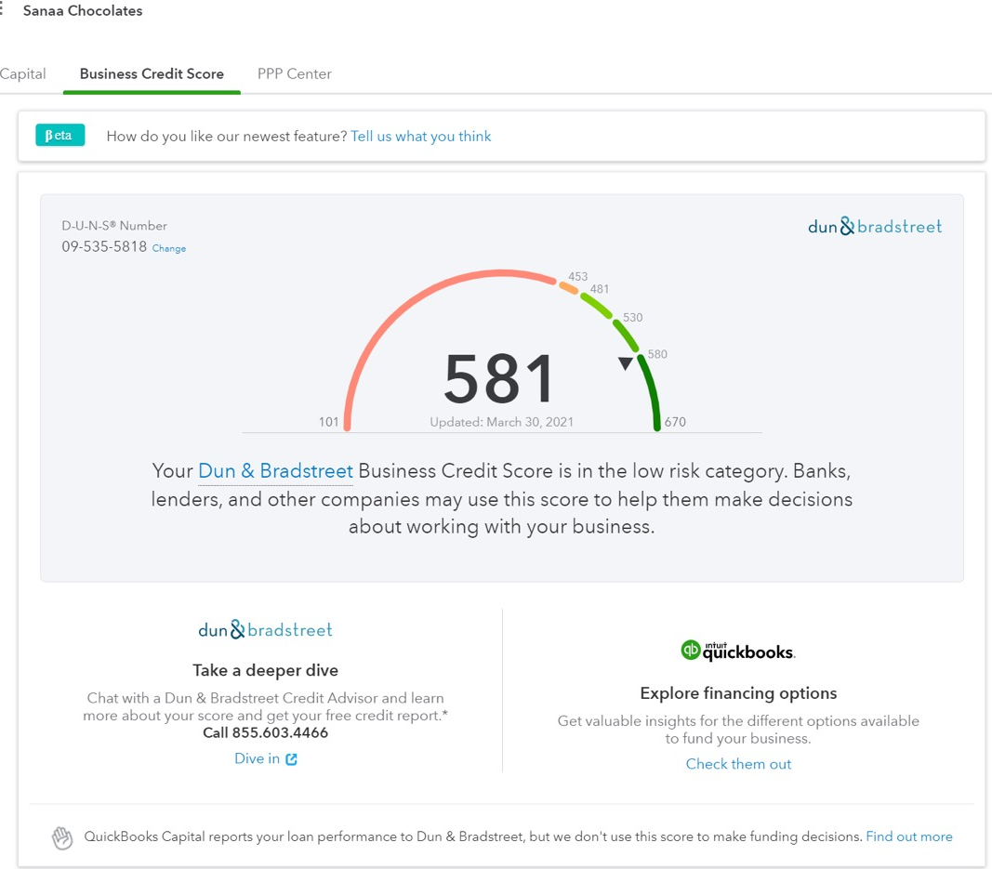

- Resource Needs

The hand-crafted and high quality nature of Bonzai’s products result from a fairly labor-intensive production process, which limits production capacity and sales potential. As a result, and based on solid performance to day, Bonzai is seeking a $25,000 loan for machinery (approximately $20,000) and packaging/logo development (approximately $5,000). Bonzai’s existing machinery tempers 5-10 lbs of chocolate in approximately 2 hours. However, a new machine—the Selmi Plus EX Automatic Tempering Machine, can temper 52 pounds of chocolate in 7 minutes. This has critical implications for output and capacity, as tempering represents the critical stage in the production process. It is anticipated that, with an enhanced production time, the co-owners will have more time to devote to packaging, marketing, promoting. The term of the loan would four years, with an anticipated interest rate of 6 percent.

