Single Member LLC Operating Agreement Template

Source: eForms, Single Member LLC Operating Agreement Template

https://eforms.com/operating-agreements/single-member/

A single-member operating agreement is a document written for a limited liability company (LLC) with only one (1) owner. The form is to be used to help solidify the LLC’s status as a separate entity from the owner’s personal assets. The owner’s role in the company, as well as any officer(s), registered agent, manager(s), and any other positions, should be listed. Once completed, the document should be held at the principal place of business and is not filed with any government office.
Notary Acknowledgment – It’s highly recommended a single member operating agreement be signed by the sole owner in the presence of a notary public in order to prove it’s authenticity and the date it was signed.

What is a Single-Member LLC?
A single-member LLC is a company that has one (1) owner and most commonly created for tax planning and to separate the owner from the assets and/or liability placed in the LLC. All revenue that is generated by a single-member LLC, and after expenses have been properly deducted, will be “passed-through” at the same tax rate as the owner’s personal level. Barring a State tax or levy, a single-member LLC does not pay taxes at the entity level. For these reasons, creating an LLC for a small business, real estate venture, or any other tangible or intangible revenue-generating asset is highly recommended.

IRS Definition
“An LLC is an entity created by state statute… An LLC with only one member is treated as an entity disregarded as separate from its owner for income tax purposes (but as a separate entity for purposes of employment tax and certain excise taxes), unless it files Form 8832 and affirmatively elects to be treated as a corporation.” (source)
To summarize, a single-member LLC is a separate entity from you personally, but it is also different from a corporation. It will be reflected on your federal tax return, but you won’t be personally responsible for its debts and obligations.

How to Form a Single-Member LLC (5-Steps)
Forming an LLC involves a filing fee and is usually can be created within a week depending on the laws and procedures in the State it’s being created. In most States, the process is as follows:

Step 1 – Search for Duplicate Names

Search the name of the LLC in the State business database. Before starting the process it’s recommended to research the name of the LLC before filing for registration. Each State has an office, most commonly the ‘Secretary of State’, that controls the incorporation of entities. In this department, there is an online portal that allows a user to look up a name and see if there is a company, corporation, or partnership that is already in existence with the name selected.
- Name Reservation – In most cases, if there are no common matches, the name will be available. If the applicant wants to be sure their name is available before filing, they can file a “Name Reservation” for a small fee which will secure their name for a period of thirty (30) to one-hundred and twenty (120) days depending on the State.
- Trademark Office (USPTO) – It is recommended to conduct a search in the USPTO Trademark Database to ensure the name of the business is not already registered for its usage. Remember that if a name is trademarked, you cannot use the name attached to its specific use. For example, a business cannot register as the name of “Nike LLC” and make sneakers in Montana.

Step 2 – Complete the ‘Articles of Organization’

The Articles of Organization is the official term for the application which is now online in most States. When applying, be prepared to answer the following:
- Effective Date – The 1st day of business.
- Request for “Certificate of Status” – An official document or seal.
- LLC Name – Must end in “Limited Liability Company”, “L.L.C.”, “or “LLC”
- Mailing Address
- Manager(s)
- Officer(s)
- Principal Place of Business – The main office.
- Purpose of Business
- Registered Agent – Representative of the Company. It can be the owner but is recommended to be their legal counsel.
Select your State and use the guide to create an LLC and only pay the State required fees.

Step 3 – Pay Filing Fee

Each State has a filing fee that is required to register the LLC ($50 to $800). Be sure to pay the fee online or by sending a check to payable to the appropriate State office. Payment of the fee will mark the end of the registration process with the new entity taking anywhere from 5 to 30 days to process.

Step 4 – Write a Single-Member Operating Agreement

The form is the only document that outlines the ownership of the business. It is written as protection from any partners, employees, spouses, or any other individuals from claiming they were promised ownership (verbally). In addition, it’s recommended a notary public acknowledge the signature of the single owner.

Step 5 – Get an EIN (Employer Identification Number)

After the LLC is created, this is the first (1st) to do. An Employment Identification Number (EIN) is required for the business to open bank accounts and pay taxes. Therefore, the LLC will not be able to generate any money until this is complete. It’s free and can get an EIN online in 15 minutes or send the paper application in the mail.
- Online Application – www4.irs.gov/modiein/individual/index.jsp
- Mail-in – IRS Form SS-4 (instructions)
Upon successful registration of the EIN, the LLC is ready to begin conducting business transactions.

LLC vs Sole Proprietorship
The main difference is with an LLC the owner is free of personal liability due to the company acting as a “shield” from legal and financial liability to the owner. While in a sole proprietorship, the business owner remains liable for all financial and legal ramifications of negligence, lawsuits, and any other type of exposure.

LLC
- Allowed to hire employees;
- Acts as a separate entity;
- Can create bank accounts;

Sole Proprietorship
- Not allowed to hire employees unless the owner gets an EIN;
- Does not act as a separate entity;
- Can only create bank accounts under a DBA or under a personal name.

Frequently Asked Questions (FAQ’s)

Does a Single Member LLC need an Operating Agreement?
Only in the States of California, Delaware, Maine, Missouri, and New York.

How does a Single Member LLC pay Taxes?
A single-member LLC does not pay taxes on the company-level (unless there is a State LLC tax). The profits from the LLC pass-through to the sole owner and is paid on their IRS Form 1040.

Can a Single Member LLC be an S-Corporation (S-Corp)?
Yes by filing IRS Form 2553 within 75 days of the effective date.

Can a Single Member LLC be a C-Corporation (C-Corp)?
Yes by filing IRS Form 8832.

Can a Married Couple be in a Single-Member LLC?
No. By definition, a single-member LLC only has one (1) owner. Although, adding a spouse requires amending the entity’s operating agreement.

Can you Sell a Single Member LLC?
Yes, the owner can sell the entity just like any other business.

Can a Single Member LLC add Members?
Yes, a single-member LLC can add members. Although, this will make the entity a multi-member LLC which will require amending the operating agreement.

Can a Single Member LLC hire Employees?
Yes. The term single-member only refers to their being 1 owner. There can be as many employees as the owner desires.

Can a Single Member LLC pay Rent to the Owner?
Yes. A single-member LLC can pay rent to the owner if, for example, the owner is also the landlord. Although the property cannot be in the same single-member LLC, it must have separate ownership.

Do Single Member LLC’s pay Quarterly Taxes?
Yes. Due to the single-member paying self-employment taxes on the income being received, it’s required to pay the estimated tax throughout the year (April 15 June 15, September 15, and January 15). This can be completed by registering with the IRS through their Online Portal (EFPTS).

How to Write a Single-Member LLC Operating Agreement
Download: Adobe PDF, Microsoft Word (.docx), Open Document Text (.odt)
1 – Save This Operating Agreement To Solidify The Sole Member Of An LLC
Download the Operating Agreement as a PDF or word processing file using the buttons featured with the preview image. Notice, each button will carry a file-type label. This will be the format, the paperwork you obtain will be in when you click that button. Select the button appropriate to your needs then save the file.

2 – Complete The Official Title Of This Agreement
Notice the title of this agreement. It will only be complete after you have provided two items. First, record the name of the Limited Liability Company on the first blank line of this title. 
Enter the words “Single Member” on the second blank space. 

3 – Supplement The Introduction With A Description Of The LLC
The first paragraph developed for this agreement will need to present the exact calendar date when it was entered. The first two blank spaces will require you report the calendar month, day, and year that defines this date. Continue through this statement by supplying the names of the parties involved here. In this case it will be the Sole Member of the LLC and the LLC itself. The full name of the Limited Liability Company as it should be known to your local state government, the federal government, and the public must be supplied to the blank line just after the word “…Among” and before “LLC…” You must properly categorize the type of Limited Liability Company we are discussing within this introduction. To this end, submit the type of LLC this is. In this case, it will be the “Single Member” Finally, your full name as the Sole Member of the LLC being discussed must be recorded on the final blank line of this statement. 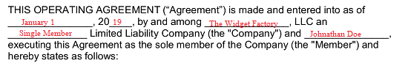

4 – Officially Establish The Single Member Limited Liability Company
Several articles will make up this document. The first article, “1. Organization,” will discuss the origin of the Sole Member Limited Liability Company and require information to appropriately supplement its language. You must define the type of Limited Liability Company we are discussing. Do this by entering the words “Single Member” to the first blank space.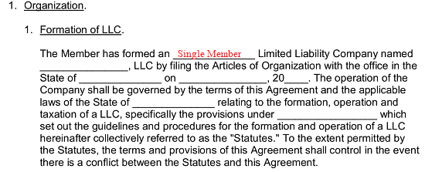
The full name of the Limited Liability Company must be displayed on the second blank space in this article. This name must recorded precisely as it appears in the title of this document and the introduction. 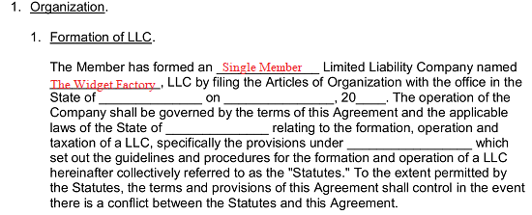You will need to attend to the remainder of this statement by documenting the state where the Limited Liability Company is formed on the empty line after the term “…The Office In The State Of” and making sure the next two blank spaces display the concerned LLC’s date of formation. 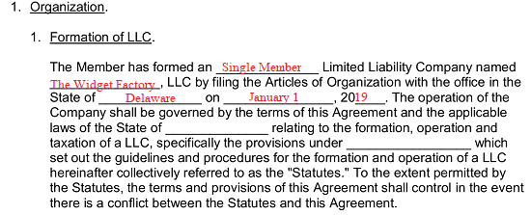The next two spaces will provide the terminology necessary to solidify your entity’s compliance with the law. Record the name of the state that shall govern the LLC’s operations on the blank space following the phrase “….Applicable Laws Of The State Of” then report the reference information required to review that state’s statutes on how an LLC may operate on the final blank line of this paragraph. 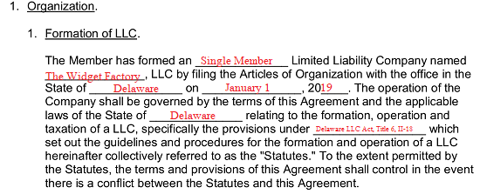

5 – Define The LLC’s Purpose, Member Authority, And Governing Law
Now, the reason why this LLC is being formed will need to be solidified. This may be a company based on providing a service, a product, or both. Make sure you define the overall purpose of the LLC on the first blank line in the second article (“2. Purposes And Powers”). Keep in mind that your entity must operate and behave within the confines of the laws that will govern it.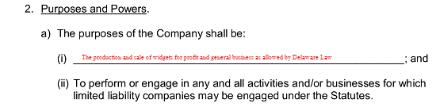Make sure you read every article whether it requires your input or not. You will be held accountable to their contents once you sign this document. Once you arrive at the ninth article, you will need to supply some material to complete its statements. “9. Rights, Powers, And Obligations Of Member” will contain one blank line in the section labeled “A. Authority.” If you are the Sole Member of this LLC, then supply your name to this space precisely as it appears on your official I.D. Only the name of the Sole Member of the LLC should be entered to this space. 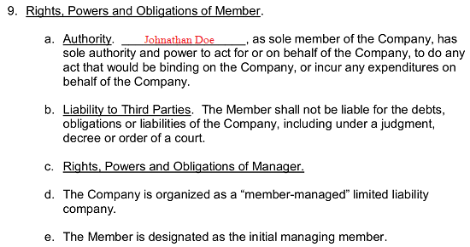Take the time to review articles 10 and 11 then proceed to the area labeled “F. Governing Law” in the twelfth article (“12. Miscellaneous Provisions”). Here, you must record the name of the state where the LLC is formed and governed on both blank spaces in this area.

6 – The Single Member Must Execute This Document With A Notarized Signature
The final area of this document will allow you to solidify your intent of being the Sole Member of the Limited Liability Company being formed. This process of execution will begin with the act of signing your name to the completed template before a Notary Public who will verify several facts below your signature.
First, you must print the name of the Sole Member Limited Liability Company to empty line just underneath the “In Witness Whereof…” statement. Your full name must be signed on the line labeled “Managing Member’s Signature.” Only the Sole Member of the Limited Liability documented above can sign this line. Print your name on the blank space directly below your signature then release possession of this paperwork to the attending Notary Public. 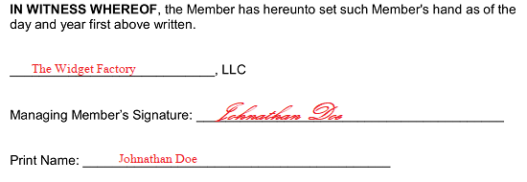The bold heading “Acknowledgment Of Notary Public” will contain the area where the notarization process will occur. Here, the Notary Public will solidify the location and document the date of this signing. Then he or she will fill in the name of the attending party (you) and supply his or her credentials. In many cases, the Notary will stamp this document in the blank area provided to him or her. 


