14 Affordable or Free Market Research Tools and Resources
- Nemanja Jovancic
- Mar 28 2019
- No comments
Market research. Often difficult to deal with but impossible to do proper business without.
Whether you’re looking to launch a new product, feature or service, break into a new market, open a new store, without doing proper market research you’re highly likely to fall short of your business objectives.
With the development of technology and new market research tools emerging every day, it’s become more difficult than ever to decide on which ones to use for your marketing efforts (especially if you’re on a tight budget).
That being said, I’ve prepared a selection of 14 helpful and affordable market research tools and resources to use. The tools are divided into different subcategories and include short descriptions and pricing details.
Let’s dig in.

Top 14 Market Research Tools and Resources

Survey and Poll Based Market Research Tools

1. Pickfu
Pickfu is a poll-based market research tool that enables you to easily obtain feedback from your potential customers. What it does, basically, is A/B test your ideas so as to decide on the best variation. It can show you what people like and what they don’t.
For instance, you can use Pickfu to choose the most appealing book cover and title before publishing, to validate your business ideas, test different logo and ad variations, improve your product listing photos and descriptions, optimize your app’s UI, and so on.
Price: $1 per response

2. LeadQuizzes
LeadQuizzes is a platform built for marketers, small businesses and entrepreneurs to help them increase leads and easily learn more about their audience using quizzes and surveys.
By creating and using highly visual surveys, you will be able not only to generate thousands of new leads but also to segment your audiences into different customer groups based on the responses they give.
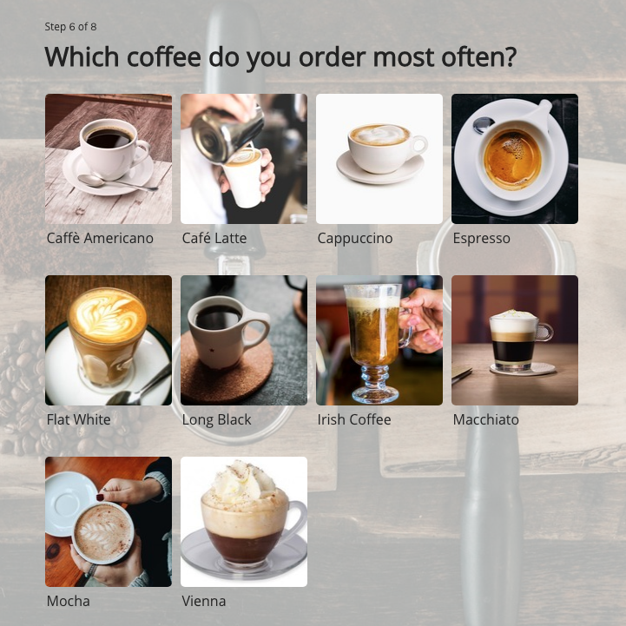<img class="aligncenter wp-image-4572" src="https://www.leadquizzes.com/wp-content/uploads/2019/03/coffee-survey.png" alt="LeadQuizzes Survey" width="721" height="721" />
Thanks to the market data you obtain this way, you should be able to segment your target audience and aim a particular marketing strategy at each of the groups based on their personal characteristics and preferences.
LeadQuizzes enables you to integrate your surveys with your favorite marketing tools and seamlessly share data between those so as to save both time and money. For example, you can integrate your survey with an email automation tool and, based on the results they get, send your customers personalized email sequences to move them further along your sales funnel.
If you’d like to learn more about how to create your own quizzes and surveys and use them to obtain reliable market research data, here’s a detailed quiz maker instructions for you to check out.
Price: Free to try, starting at $29/month

Buyer Persona Research Tools

3. Think with Google
Think with Google is one of those market research tools that can provide you with all the insights, data, and trends that you need. Innovative as always, Google has launched a platform that offers data-rich insights on how people browse and buy.
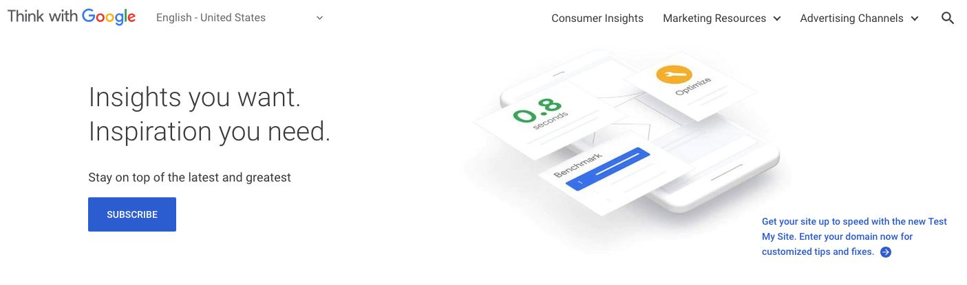<img class="aligncenter wp-image-4576" src="https://www.leadquizzes.com/wp-content/uploads/2019/03/Screen-Shot-2019-03-26-at-12.58.18-PM.png" alt="Think with Google - market research tools" width="1405" height="416" />
If you’re looking to learn more about how consumer behavior changes due to digital innovation and depending on a season, holiday, or any other specific event, this might be the right market research tool for you.
Google is basically doing everything for you, you just need to access the data they are already exploring and the trends they are already tracking and you’ll have a behind the scenes look at your potential customers’ behavior.
For the best results and most comprehensive data, you should consider using Thing with Google in combination with other Google’s market research tools like Shopping Insights, Google Trends, Consumer Barometer, and Market Finder.
Price: Free

4. Facebook Audience Insights
Audience Insights is a free market research tool powered by Facebook that enables you to learn more about your current target audience or discover a new one.
It allows you to create audience personas and acquire consumer insights on the basis of the persona you’ve created. These insights can be used to create Facebook ads or for market research purposes.
Facebook Audience Insights can be used to obtain data on age and gender, relationship status, education level, job title, and so on.
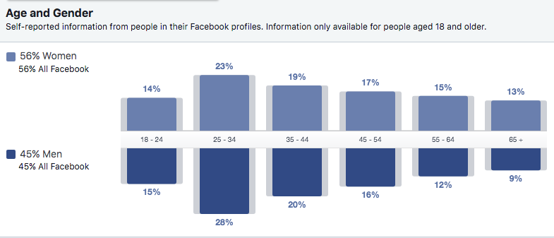<img class="aligncenter wp-image-4574" src="https://www.leadquizzes.com/wp-content/uploads/2019/03/Screen-Shot-2019-03-28-at-4.57.31-PM.png" alt="FB Audience Insights" width="785" height="337" />

5. MakeMyPersona
MakeMyPersona is one of the market research tools from HubSpot’s marketing toolbox. It lets you create buyer personas by providing answers to a series of questions based on already existing market research.

Keyword Research Tools

6. Google Keyword Tools
Google Keywords are your window to the web market research. This tool shows you the volume of keyword searches, how competitive they are, related keywords, and all the basic information you need to learn how to market your services online.
Price: Free

7. Ubersuggest
With its simple interface and no sign-up needed, Ubersuggest is one of the simplest market research tools for performing keyword and content research. Just enter a keyword or phrase and it’ll create a list of related keywords in alphabetical order.
Price: Free
Here, I’ve included the free tools only, but of course, you should consider other analytics and feature-rich paid solutions such as Ahrefs, Moz, and SEMRush.

Market Research Data Resources

8. American Fact Finder
American Fact Finder is an excellent resource for finding the United States census data (if the US is your target market, of course). The US Census contains a plethora of information on people, companies, places, and trends. Plus, you can filter that information by age, location, race, income, and year.
<img class="aligncenter wp-image-4573" src="https://www.leadquizzes.com/wp-content/uploads/2019/03/Screen-Shot-2019-03-27-at-11.11.38-AM.png" alt="American Fact Finder" width="861" height="341" />
All of this makes the American FactFinder an easy way to find the most relevant census data about your customers and a powerful market research tool.
Price: Free

9. Pew Research Center
The Pew Research Center website has a huge database of free research, ranging from political attitudes and economic situations to social media usage and marketing statistics. This research can be used as a powerful market research tool that helps you better understand your target audience and track key market trends.
Its sleek user interface and interactive charts that can be hovered over to reveal additional data make the Pew Research Center more than just a dull aggregator of facts and statistics.
Price: Free

10. Statista
Looking for sleek stat-rich graphs that reveal market research trends in almost any field? Look no more. Statista is your go-to place for all your stats and facts.
The website boasts with over 1 million stats and facts within 600 industries for more than 50 countries. It contains statistical data on more than 80,000 topics from over 22,500 sources. In addition to English, Statista is available in French, German, and Spanish.
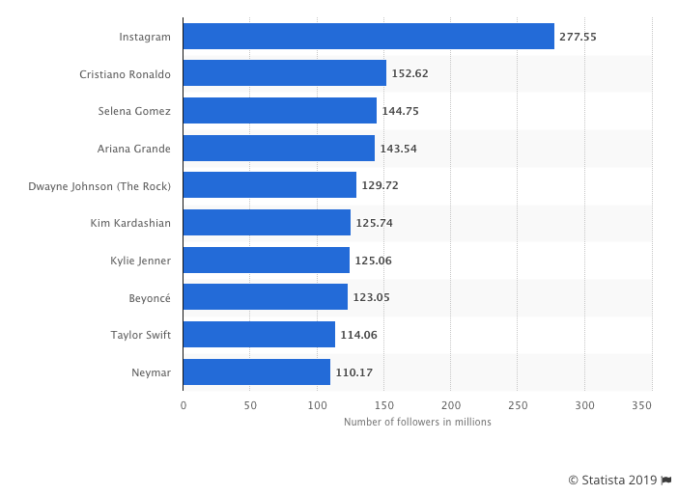<img class="wp-image-4571" src="https://www.leadquizzes.com/wp-content/uploads/2019/03/Screen-Shot-2019-03-28-at-1.16.52-PM.png" alt="Statista" width="702" height="513" />Statista: Instagram accounts with the most followers worldwide as of January 2019 (in millions)
Price: Freemium
It lets you access basic data and statistics for free but charges $49/month for access to the premium statistics.

Social Media Market Research Tools

11. Social Mention
Social Mention is a real-time social media search and analysis tool that can help you learn which topics are currently trending online. Its simple interface makes it user-friendly and easily accessible (with no registration required).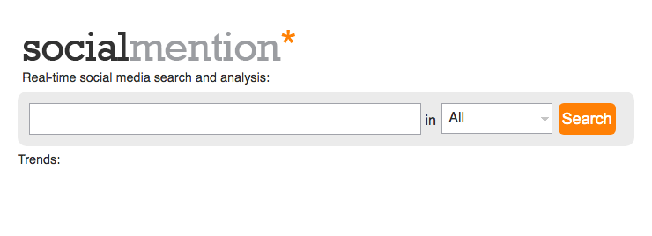<img class="aligncenter wp-image-4570" src="https://www.leadquizzes.com/wp-content/uploads/2019/03/Screen-Shot-2019-03-28-at-1.18.58-PM.png" alt="Social Mention" width="740" height="268" /> Just enter a keyword or a phrase, click “Search”, and it will show you all the recent social media posts buzzing about it. It can also show a list of related keyword ideas and a bunch of other insights. What it does, basically, is gather all the user-generated content from different social media sources and show it in one place.
Price: Free

12. Buzzsumo
Use the words ‘buzz’ and ‘sumo’ separately and you’ll probably get a hilarious mental image (a super-fast sumo wrestler just popped into my mind). Join them in one new word, however, and you’ve got yourself one of the most powerful market research tools you can use to analyze what content works best for different topics and competitors.
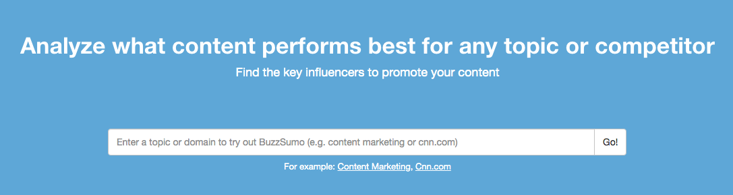<img class="aligncenter wp-image-4577" src="https://www.leadquizzes.com/wp-content/uploads/2019/03/Screen-Shot-2019-03-28-at-1.55.27-PM.png" alt="Buzzsumo" width="1087" height="291" />
If you’re looking to learn more about how to improve your social media market research game, here are 5 tips on how to use Buzzsumo in your marketing strategy.
Price: Four pricing plans starting at $79/month.

13. Quora and Reddit
From a user perspective, Quora and Reddit are great places to ask questions and get a bunch of answers from random people. From a marketer perspective, they are a blend of consumer intelligence and market research.
On both platforms, you can see what people in your market think about certain topics, what questions they have about those, and how they interact among themselves.
If you want to dig deeper, we can show you how to increase your website traffic using Reddit or how to use Quora to generate leads.
Price: Free

Market Research Data Visualization Tools

14. Tableau
Even though Tableau is not one of the market research tools per se, it can still play a valuable role in your market research efforts – it helps you visualize and better organize the market data you obtained elsewhere.
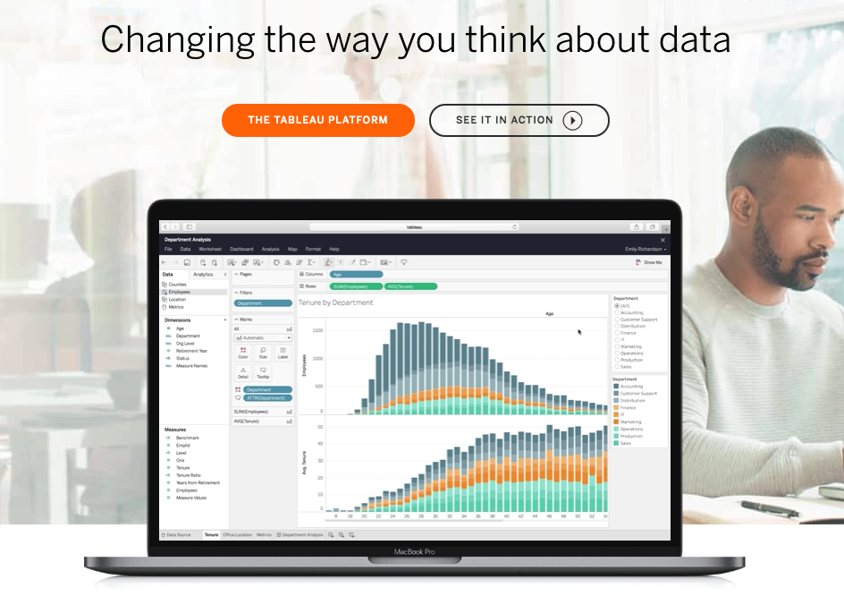<img class="wp-image-4575" src="https://www.leadquizzes.com/wp-content/uploads/2019/03/Screen-Shot-2019-03-28-at-3.38.36-PM.png" alt="Screen Shot 2019 03 28 at 3.38.36 PM" />
Tableau uses analytics, visualization, and business intelligence to help you better understand your market research data and “change the way you think about it.” This data visualization tool enables you to create a shareable interactive dashboard which presents different trends and variations in colorful charts and tables.

