THREE STEPS TO MANAGING A SUCCESSFUL SOCIAL MEDIA APPROACH

- Building Audience

Your business page will link to your personal page: Set up FB profile – answer all questions
To create a Page:
- From the Pages section, click Create new Page.
- Add your Page name and category.
- Add your Page’s bio and click Create.
- (Optional) Add information, such as Contact, Location and Hours, and click Next.
- (Optional) Add profile and cover photos, and edit the action button, and click Next.
- (Optional) Invite friends to connect with your Page, and click Next.
- Click Done.

- Ask all your personal network to like and follow your account and all your posts until you develop some natural momentum.
- Start by “liking” organizations who target similar groups to you in the beginning. Grow slowly – FB will lock or cancel your account if you grow too quickly because they’ll think you’re a scammer.
- When someone “likes” your page, invite them to “follow” your page.
- Respond to posts and questions and messages immediately.
- Join relevant groups like Michiana Small Business, Support Black Owned Business, Women Owned Businesses, etc.
- Spend time each day liking and commenting on other’s pages. Find ways to complement them so that they come to your page and create activity.
- IG - It’s better to have more people following you than you follow.

- Developing Campaigns
- Humor is a powerful weapon
- Clever text is still a winner
- Invite users to collaborate
- Curate your feed
- Stick with your campaign: It doesn’t need to be an overnight success, and it takes time for people to engage so directly with a brand. If you believe it is the right strategy, hold your nerve and continue to promote the campaign for a little longer.
- Monitor trends: Customers are constantly sharing their lives and their interaction with a brand doesn’t only relate to a direct purchase. If you set up alerts for spikes in activity around specific topics or themes, you can identify these opportunities.
- Act quickly and decisively: On social media, the window of opportunity shuts quickly. Businesses need to take a risk sometimes, if they are to capture the audience’s attention.
- Take on important causes
Brands can go multimedia: Brands should not shy away from creating their own music and videos.
- Make it easy to get involved: Too many companies ask too much of their audience on social media, with no clear incentive for their customers.
- Use a meaningful hashtag: We have all seen brand hashtags that make little sense for anyone to share, outside of the company’s offices. This campaign’s hashtag is consistent with the charity’s purpose, while still retaining a lighthearted tone.
https://www.fool.com/the-ascent/small-business/social-media/articles/social-media-campaign/

Easy content ideas: customer quotes, before and after pictures, pictures of how your product is made, quotes that are related to your business, your motivation or people you want your business identified with

The following business are all graduates of SBEAP:

Importin’ Joe – Notice the consistency in how photos are shot – makes you feel you are going on a journey with a friend that entices you come along.
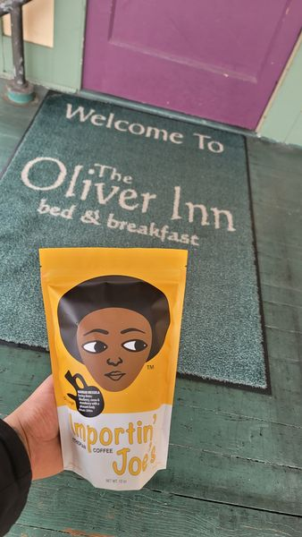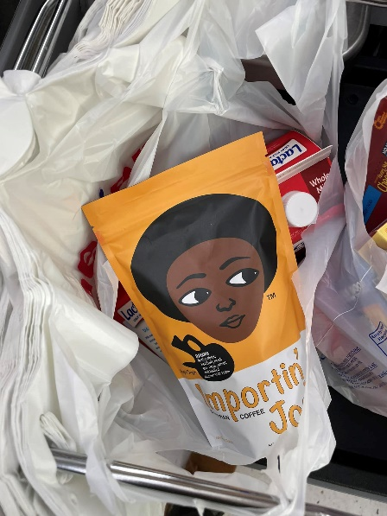

Heavenly Sent See Moss is taking a different approach, trying to build understanding about the product and its benefits.
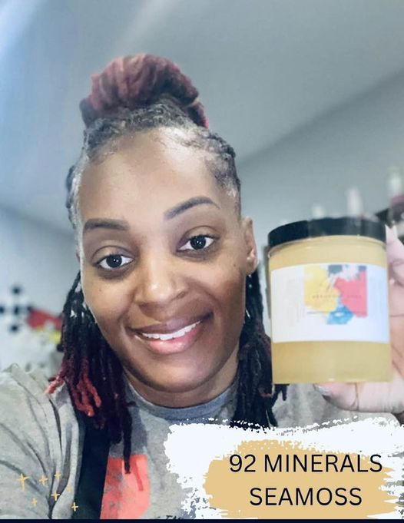

Reba J. Perspectives does a good job showing the range of her photography she can do, while maintaining a consistent look.


Don’t mix personal with professional unless it’s an intentional part of your branding. Also, beware, the way you present yourself on your personal profile may impact how people perceive your brand.
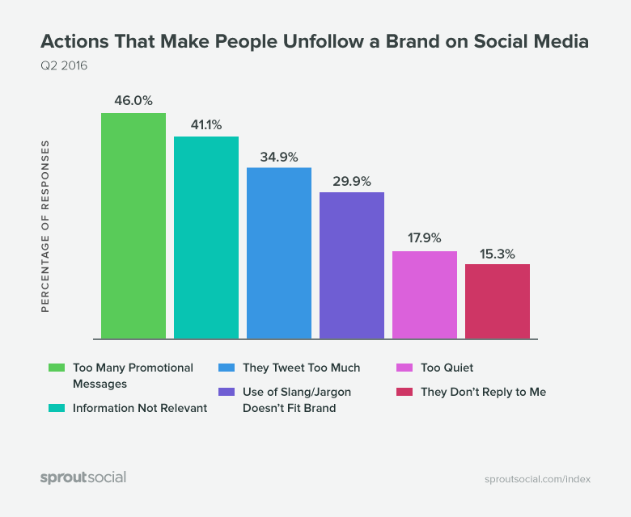

This is a good example of how to engage viewers. Ask questions to engage viewer thoughts & opinions.



Take advantage of the Planner tool available in Facebook that enables you to schedule posts ahead for both Instagram and Facebook. It will let you know about holidays coming up, and once you hit 100 users, it will tell you the time your users are most active.
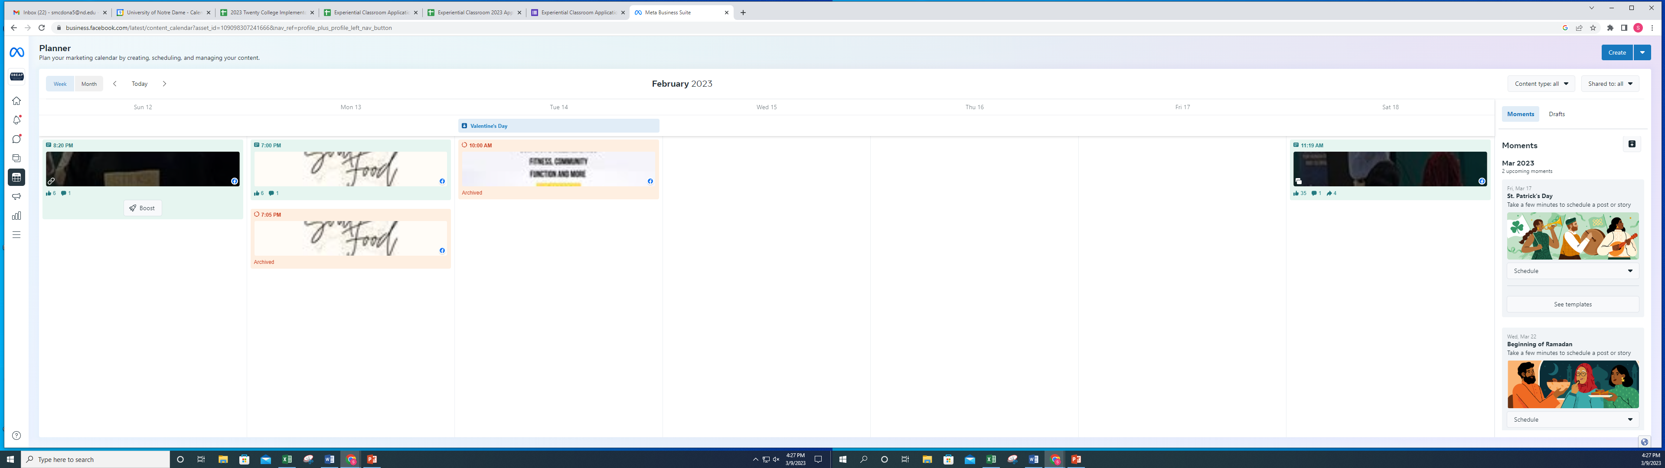

Consider what goals you have for your FB posts, and what are the best way to achieve those?

- Brand awareness (growth, engagements) and consideration (link clicks, web traffic)
- Lead generation (marketing qualified leads)
- Competitor analysis (share of voice)/Market share
- Audience engagement (likes, replies, shares, etc…)
- Drive customer loyalty (+ CX) and reduce churn
- Customer service efficiencies (engagement speed and rates)
- Find new sales opportunities (conversations to join)
- Uncover brand expansion opportunities
- Reputation management (engaging with inbound messages)
- Increase customer satisfaction
- Product launch analysis
- Social recruiting to hire high-quality staff
- Donor recruitment (increase membership) and retention
- Recruit more volunteers
- Build cause and brand awareness (impressions and reach)
- Audience engagement (likes, replies, shares, etc…)
- Drive event attendance
- Inspire audience support
- Increase board member buy-in with compelling data
- Customer satisfaction
- Positive reviews
- Reputation management

- Winning the Algorithm Game (Getting Your Business to Pop Up When People Open Their Social Media)

Be responsive to clients online. The various platforms will reward you for timely responses and penalize you by making your posts less visible if you do not respond.

Hashtags act like magnets – it will attract people to what you have #buylocal #womenowned #minorityowned or topical words or ideas like: #organic #affordablehousing

Hashtag basics
- They always start with # but they won’t work if you use spaces, punctuation, or symbols.
- Make sure your accounts are public (not restricted to your friends). Otherwise, the hashtagged content you write won’t be seen by any non-followers.
- Don’t string too many words together. The best hashtags tend to be relatively short and easy to remember.
- Use relevant and specific hashtags. If it is too obscure, it will be hard to find and it won’t likely be used by other social media users.
- Limit the number of hashtags you use. More isn’t always better. It actually looks spammy.

Why use hashtags?

Increase engagement with your followers
Including hashtags in your posts means taking part in a conversation happening on that social media platform. And most importantly, it makes your posts visible in that conversation. This can lead to greater engagement, boosting your brand’s social media engagement through likes, shares, comments, and new followers.

Build brand awareness with branded hashtags
Creating a branded hashtag can be an effective way to promote your business and drive conversations. Branded hashtags can be as simple as using your company name or incorporating a tagline into a hashtag.

Tags - When you create a post, if you use “@” and then the person’s online name, it will create a link to their timeline, effectively connecting you to their audience, and expanding your own. You can also tag pictures of people with the same effect.
